**Chapter 1**

**INTRODUCTION**

This chapter contains a brief introduction about Parkinson disease. The literature review, and scope of work is given. The objectives of the project and metrics used are discussed.

**1.1 Parkinson Disease**

Parkinson disease (PD) is a disease that results in shaking and stiffness due to brain disorder that is caused by the impairment of neurons that control movement. It occurs as a result of degeneration of neurons that are responsible for producing dopamine in particular areas of human brain known as substantia nigra which affects the motor function. Over 10 million people around the world suffers from Parkinson disease and the effect of the disease increases with age. Parkinson's symptoms usually begin gradually and get worse over time. As the disease progresses, people may have difficulty walking and talking. They may also have mental and behavioural changes, sleep problems, depression, memory difficulties and fatigue.

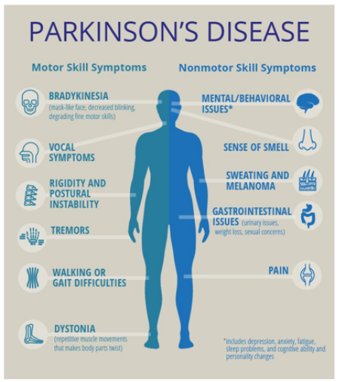

**Fig. 1.1 Parkinson disease**

**1.2 Scope of work and importance**

The difficulty that medical science is currently facing is the early diagnosis of Parkinson disease in the affected people. Even if the disease worsens, patients who receive an early diagnosis can enhance their quality of life. However, this is challenging because Parkinson disease symptoms overlap with those of other illnesses, making it possible for Parkinson disease to go unnoticed or, worse, to receive an incorrect diagnosis. Another difficulty is that the diagnosis of Parkinson disease generally entails a number of steps, including acquiring a thorough neurological history of the patient and observing the patient's motor skills in various contexts. Not to mention the complete lack of a reliable laboratory test for the diagnosis of Parkinson disease, which makes a diagnosis in the early stages of the disease when the motor symptoms aren't severe enough to be detected, practically difficult. As a result, regular visits from the patient are necessary for accurate diagnosis and tracking of the patient's development.

Any way to diagnose Parkinson disease withoutcontinual clinic visits would be more than appreciated by patients and would prove to be beneficial for them. As Parkinson disease patients show unique and characteristic vocal features, their voice recordings would prove to be an invaluable procedure for diagnosis as it is also non-invasive. Hence, tests using speech prove to be a good tool to audit Parkinson disease. This opens up an entirely new door of opportunities for Machine Learning algorithms to work on in-house voice recording datasets of Parkinson disease patients and then go on to efficiently predict or diagnose Parkinson disease. Voice features from the audio clips can be extracted by passing the recordings through signal processing algorithms and these features can be used to build a classification and regression model to predict a rating on the Unified Parkinson’s Disease Rating Scale (UPDRS). UPDRS, which indicates presence and progression of Parkinson disease, has been as the most used scale for measuring and assessing Parkinson disease [5].

Micrographia, or tiny, crowded writing, is a defining feature of Parkinson's disease and typically one of the first symptoms. Parkinson's disease is diagnosed with the aid of spiral hand motions. During spiral hand movements, surface pressure and grip angle are mapped to kinematic variables and transformed into large data set that aids in the identification of a motor problem brought on by Parkinson's disease (PD). Therefore, spiral drawing is another important dataset which helps in the prediction of Parkinson’s disease.

**1.3 Literature Survey**

Prediction of Parkinson disorder is one of the most important problems. The disease needs to be detected in the early phases of the commencement of the disease so as to reduce the disease progression rate among the individuals. Lots of pre-processing, feature selection and classification techniques have been implemented and developed in the past decades.

Mohesh T et al. (2022) [2] proposed “Parkinson Disease prediction using machine learning”, where different techniques are used to classify whether a person has Parkinson disease or not. The dataset available on University of California ,Irvine (UCI) Parkinson Data-set was used. The voice dataset of Parkinson's ailment from the UCI device mastering library was used as input. Additionally, the proposed device presents correct results with the aid of integrating spiral drawing inputs of regular and Parkinson’s affected sufferers. They advocate for a combined and precise reading of the subject's voice and spiral drawing data. Various machine learning algorithms like Logistic Regression, Support Vector Machine (SVM), Ada Boost, Gradient Boost, Random Forest, Naive Bayes, Neural Network, XGBoost and Decision Tree were implemented. Here building a classifier using Decision Tree results in an accuracy of 94.7774555%.

Some of the other evaluation metrics used include PCA and EDA (TSNE visualization). In decision tree an introduction of sub-nodes will increase the homogeneity of resultant sub- nodes. In other phrases, it can be said that the purity of the node increases with admire to the target variable. More data instances can be obtained to train the model which would lead to better accuracy.

Timothy J Wroge et al. (2018) [9] discussed “Parkinson disease diagnosis using machine learning and voice”, where data is collected through mPower, a clinical observational study conducted by Sage Bionetworks using an iPhone app. The method used for collecting the audio data was a smartphone voice activity that recorded participants articulating the phoneme for 10 seconds. Each participant was uniquely identified with a distinct health code. Prior to being fed into the feature extraction algorithms, the raw audio is cleaned with VoiceBox’s Voice Activation Detection (VAD) algorithm, to extract and remove background noise of the audio. The cleaned audio was then passed through two separate algorithms for feature extraction before being input into the machine learning. A diverse range of machine learning classifiers were examined to find the highest categorical accuracy for PD diagnosis.

The decision tree and support vector machine classifiers were developed with the help of the Scikit-Learn. A series of decision tree classifiers were used to classify the dataset including standard decision trees, random forest, gradient boosted decision trees and extra tree classifiers. The training and testing set were split 90% training and 10% testing.

All models used stratified 10-fold cross validation in order to eliminate bias in splitting the testing and training set. These models were then tested for accuracy. The best classifier based on the data provided was found out to be Gradient Boosted Decision Tree. This model seems to be especially effective in classifying the dataset as well as maintaining high values of precision. The accuracy was found to be 86%.

The range of voice related symptoms is promising for a potential detection tool because recording voice data is non-invasive and can be done easily with mobile devices. With more patient driven data, the accuracy of these models’ using speech as a biomarker for disease can be improved. There are clear limitations to speech as a single biomarker for clinical diagnosis, but given the success of this model and others, it was optimistically concluded that algorithms that incorporate multiple modalities, such as speech, brain scans, or accelerometers could be used in concert to create a robust clinical tool to aid neurologists in diagnosing Parkinson disease and Parkinson disease like symptoms.

Anik Pramanik et al. (2020) [15] proposed “Parkinson disease detection from voice and speech data using machine learning”. The features in the data-set include fundamental frequencies, harmonicity variants, time frequency attributes, wavelet and vocal based features and many other speeches signal data, all totalling no less than 750 attributes of 252 persons. The data-set, on which the proposed model was tested, was publicly available as PD Speech data-set from Department of Neurology in Cerrahpasa, Faculty of Medicine, Istanbul University. Different data-processing techniques like data standardization, Multicollinearity Diagnosis, Principal Component Analysis (PCA) and Independent Component Analysis (ICA) were being used. Different ML classifiers like random forest, support vector machine, logistic regression and adaBoost with different combinations of hyperparameters were used to yield the best performance of the model. SMV showed the highest overall performance with accuracy 94.1%. Few of the evaluation metrices used include PCA and ICA for data pre-processing and accuracy. The proposed model can be used as a widespread tool for prediction of Parkinson’s Disease with great efficiency and accuracy. For future works, they suggested the model can be used as a web application with user-friendly UI.

Srishti Grover et al. (2018) [10] proposed, “A Review on Predicting Severity of Parkinson's Disease Using Deep Learning”, which has become a popular technique for effectively analysing unstructured data like speech and audio signals. Here deep learning is used to analyse voice data of the patient to classify it into “severe” and “not severe” classes. The voice data collected from the Parkinson disease patients for analysis was normalized using min-max normalization. In the next step, deep neural network is designed with input layer, hidden layers and output layer. The number of neurons in the input layer is fixed as the number of attributes in the input data. The output layer contains two neurons corresponds to the two classes – “severe” and “non-severe”.

The normalized data is fed into the constructed deep neural network for training and testing. The DNN algorithm takes in the input dataset and creates an input pipeline and defines iterators over it, after defining the input pipeline. The second step is to feed the input data into the training model, this is done with the help of lambda function. The model after getting data performs training, evaluation and prediction.

The evaluation metrics used in this research are the two UPDRS (Unified Parkinson’s Disease Rating Scale) scores - total UPDRS and motor UPDRS scores. The motor UPDRS evaluates the motor ability of the patient on a scale of 0-108, whereas total UPDRS provides a higher range of the score scale ranging from 0-176. The proposed DNN model achieved better accuracy compared to other existing techniques. The accuracy of their approach can be further improved by implementing it on a larger dataset, having a greater number of instances of each severity class as well as on a combined database of patients’ voice data and other patient attributes like gait and handwriting features.

Sanghee Moon et al. (2020) [6] proposed “Classification of Parkinson’s disease and essential tremor based on balance and gait characteristics from wearable motion sensors via machine learning techniques: a data-driven approach”. This retrospective database study includes a total of 1468 people tested at the Parkinson’s Disease and Movement Disorder Clinic of the University of Kansas Medical Centre. Among those, 524 participants were clinically diagnosed with PD. Six IMU sensors were worn by participants.

The study was done using the instrumented stand and walk test (iSAW) - participants were told to remain motionless for 30 seconds, move comfortably for 7 metres (m) straight ahead after hearing a beep, turn 180 degrees around at the end of the 7-m marker, then move back to the starting point. A total of 130 balance and gait features were automatically computed using the Mobility Lab software.

The classification models included Neural Network(NN), Support Vector Machine(SVM), K-Neighbour’s Classification , Decision tree (DT), Random forest (RF), gradient boosting classifier (GB) and Logistic Regression(LR). To find out the optimal values of the hyper-parameters of the classification models, they used a stratified 3-fold cross validation with grid search strategy.

The classification models were evaluated with accuracy, recall, precision and F1 score. In this study the neural networks outperformed all the other algorithms. Wearable sensors for balance and gait assessments can be implemented in movement disorders clinics to produce a vast amount of potentially informative data for assisting in diagnosis and monitoring disease progression. With further validation, a data-driven approach using machine learning techniques may provide a more efficient diagnostic and prognostic tool that can assist in the clinicians’ decision-making process.

Basil K Varghese et al. (2019) [8] worked on “Prediction of Parkinson’s Disease using Machine Learning Techniques on Speech dataset” and the UCI ML repository was used to obtain the dataset. The dataset used in this study consists of characteristics extracted from voice recordings of 42 individuals with early signs or symptoms of the disease. The goal of this work was to use a variety of machine learning techniques to reliably predict the motor and total UPDRS scores.

The data's dimension was then decreased using Principal Component Analysis. Next, the information was divided into a training dataset and a test dataset. The training dataset is used to fit the ML and neural network algorithms. They employed SVM (Support Vector Machine), Decision Trees, Linear Regression and Neural Networks for the same objective.

One of the most used accuracy measures for prediction problems to validate the work was used, the Root Mean Squared Error. The programme computed the RMSE values of the motor and total UPDRS for the forecasts. Support Vector Regression had the greatest results when compared to the other 4 machine learning algorithms. The dataset was used to train a variety of machine learning models and its accuracy was evaluated. Additionally, the ML algorithms were compared in relation to the specific data. Researchers were successful in predicting the UPDRS results with the desired accuracy. The current approach has the drawback that proper Parkinson's diagnosis will always require human interaction, intellect and experience, regardless of how automated the Parkinson's prediction process gets. The dataset might be modelled on other, better machine learning models in the future to increase prediction accuracy.

Muhtasim Shafi Kader et al. (2022) [12] proposed “Parkinson’s Disease Detection Analysis through Machine Learning Approaches”, which made use of 195 datasets on Parkinson's disease collected from the UCI machine learning repository. There were 24 properties provided when using the dataset. Furthermore, Naive Bayes, Adaptive Boosting, Bagging Classifier, Decision Tree Classifier, Random Forest Classifier, XBG Classifier, K Nearest Neighbor Classifier, Support Vector Classifier and Gradient Boosting Classifier were the nine machine learning algorithms which were used to predict the disease as accurately as possible. Evaluation metrics was used to compute the study of outcomes. They found the best possible accuracy among them through Confusion Metrics Analysis using Cross Validation which is depicted in Fig. 1.7 It was found that K Nearest Neighbor Classifier (KNN) outperformed all other classifiers in terms of performance with 97% of accuracy. Detecting the disease in early stage could be great help for the affected people.

Anitha R et al. (2020) [5] used Machine Learning techniques to detect Parkinson’s disease early. In this, the voice dataset of Parkinson's disease from the UCI Machine learning library was used as input. Additionally, the proposed approach produced precise results by combining the spiral drawing inputs of healthy individuals and Parkinson's sufferers. When they analysed patient speech and spiral drawing data, they presented a hybrid model and got precise findings. From these drawings Random Forest classification algorithm was used which converts the drawings into pixels for classification and the extracted values were matched with the trained database to derive various features.

The predictive analytics framework is a combination of K-means clustering and Decision Tree. The output for voice data analysis resulted with an accuracy of 88 % K-Means and in hybrid architecture with an accuracy of 83% for random forest classification. Their work aimed to cover a broader space of imaging and machine learning technologies for mental illness diagnosis such that researchers in the field could readily identify the state of the art in the domain.

Amreen Khanum D et al. (2022) [1] discussed “Parkinson disease detection using machine learning algorithms”. In this the Parkinson disease data provided by the UCI Machine Learning Repository consisting of 195 patient data with 23 features of voice data set was made used. Then various techniques were used to eliminate duplicate information, conflicting data, noisy, incomplete data and to boost the network's classification efficiency and redundant values.

In this work, five supervised learning techniques were used for the detection of Parkinson disease which include decision tree classifier, logistic regression, Naïve Bayes, KNN classifier and XG boost.

The distinction between them is done based on measurement criteria, namely classification accuracy, F1-score, Recall, Precision, R2-score. And it was inferred that KNN achieved the highest performance with an accuracy of 96%. This analysis has used five machine learning techniques for the detection of Parkinson disease based on several parameters. This application will be able to detect in Parkinson disease in very few minutes and notify dangerous probability of having disease. In very minimal steps it can predict if the person is healthy or PD patient.

Ifeoma Oduntan (2021) [14] proposed “Prediction of Parkinson’s Disease Using Biomedical Voice Measurements Dataset”. Vocal measurement of 195 instances and 24 attributes from 31 people were obtained. And 23 out of them had Parkinson’s Disease. The dataset was first loaded into the Jupyter Notebook and initial exploratory data analysis showed that there was no missing data. The cleaned data was split into train - test set at 90:10 ratio due to the small size of the dataset using 3-fold cross validation method. The XGBoost algorithm was applied using different parameter tunings to find the best estimator. The best score and parameters were extracted, and this was used in fitting the model. XGBoost inbuilt feature extraction was used in extracting feature importance after fitting the model. Confusion matrix was used in evaluating the performance of the classifier. XGBoost algorithm achieved an overall accuracy of 95%, precision score of 1.00 and recall of 0.94.

This predictive model can help health care practitioners concentrate on looking out for those features in remote areas that lack medical doctors in detecting PD as quick as possible. This is expected to reduce the rate at which the disease progresses and can be managed at early stage to give the patients a good quality of life.

Tarigoppula V.S Sriram (2013) [11] proposed an “Intelligent Parkinson Disease Prediction Using Machine Learning Algorithms”. The voice dataset for Parkinson disease has been retrieved from UCI Machine learning repository from Centre for Machine Learning and Intelligent Systems. The dataset range of biomedical voice measurements from 31 people, where 23 people are showing Parkinson's disease. The class column represents "status” which is set to 0 for healthy and 1 for PD. The data contains 5875 number of instances and 26 attributes. The dataset has been retrieved and executed in Orange software v2.0b for data visualization. Classification algorithms like k-nearest neighbor and support vector machine was implemented. It was concluded that SVM outperformed KNN with an accuracy of 88.9%.

Sabyasachi Chakraborty et al.(2020) [4] came up with “Parkinson’s Disease Detection from Spiral and Wave Drawings using Convolutional Neural Networks: A Multistage Classifier Approach”. In this study, a system design is suggested for examining wave and spiral drawing patterns in Parkinson's disease patients as well as in healthy individuals. Further, the prediction probabilities are trained on a metal classifier based on ensemble voting to provide a weighted prediction from both the spiral and wave sketch. 55 participants were gathered for the data collection process, including 27 from the Parkinson Group and 28 from the Control Group. The Spiral Drawing Test and the Wave Drawing Test were administered to everyone. The system created in this study uses two distinct convolutional neural networks (CNNs) to analyse the patterns of the drawings in the spiral and wave designs, respectively.Image augmentations were performed to increase the diversity and number of images in the training dataset.

The architecture of the system is divided into three sections: generator, convolutional neural network architecture, and meat classifiers to analyze the prediction probabilities. The complete model was trained on the data of 55 patients and has achieved an overall accuracy of 93.3%, average recall of 94%, average precision of 93.5% and average f1 score of 93.94% This model, when used in earlier stages, helps in the prediction of the disease so, treatment is possible in the early stages.

Korakanchi Madhu Mohan Rao et al.(2020) [7] proposed a technique “Parkinson’s Disease Detection Using Voice and Spiral Drawing Dataset”. The suggested approach can be utilised to analyse both patient voice and spiral drawing datasets to produce hybrid and precise findings. This hybrid technique, which combines the results from the speech and spiral drawing datasets, offers significant efficiency improvements. Using this hybrid classifier approach, enormous volumes of medical data may be examined. K-means clustering and the decision tree method are used for  audio  implementations. The UCI repository is where the voice dataset is housed.

The spiral model uses PyCharm, PCA, image acquisition, mean and median filters, segmentation, PCA, and R Programming to process the spiral images. PCA is used to extract features from the spiral drawings, image acquisition reduces noise and distortion, and PCA reduces the dimensionality of the data. R Programming is used to implement the work. The three vowels a, o, and u were the main focus of the voice data. Of 20 samples, 18 were correctly classified as the vowel a with a 90% accuracy rate. It provided a superior accuracy of 95% for the vowel o. Similarly, it provided 95% accuracy for the vowel u as well.

Supriya Kamoji et al.(2021) [3] proposed “Prediction of Parkinson’s Disease using Machine Learning and Deep Transfer Learning from different Feature Sets” where three different datasets where made use for prediction of Parkinson disease. The study was carried out in three folds, firstly Freezing of the gait (FOG) dataset which was obtained from UCI ML repository. This dataset consists of various acceleration measures obtained by collecting the data attached to the subjects (10 patients) legs and hips where different gait features affecting the movement of Parkinson patient is considered. This dataset consists of 1048575 instances and 11 attributes. The target attribute consisted of annotation [0,1,2] where there refer to not being a part of the study, being a part of the study but no freeze and being a part of the study with freeze. Here the instances with values 0 were dropped and 1 and 2 were changed to 0 and 1 correspondingly. Second dataset used was speech dataset which comprised of 195 entries and 22 attributes. It mainly consisted of different audio frequency which is used to detect the voice abnormality in Parkinson patient. This was cleaned for noise and other disturbance using praat software.

Various classification algorithm like logistic regression, decision tree, random forest, naïve bayes, extra tree classifier, k-nearest neighbours and support vector machine were implemented on FOG and speech dataset. and the different evaluation metrices used to evaluate the performance of the model include confusion matrix, accuracy, precision, f1-score, specificity and sensitivity. for the FOG dataset decision tree classifier outperformed other models with and accuracy of 94.98% and for speech dataset KNN gave the best accuracy of 97.44%.

Finally, the third type of dataset used is the spiral and the wave dataset which consists of 102 images each. A deep learning algorithm, convolutional neural network was implemented on this dataset. But as the dataset was too small to train the model, two techniques were used namely data augmentation and transfer learning. so that the model had enough data for training purpose and predicting accurate results. Different techniques used under data augmentation include horizontal and vertical flips and zooming. Resnet V1 50 model was used under transfer learning. Later it was found out that this model overfitted and to resolve this issue three methods namely early stopping, drop out and regularization were used. The metrics used to evaluate include train accuracy, train loss, test accuracy, test loss, recall, precision, and AUC score. The wave dataset outperformed the spiral dataset with a train accuracy of 93.06% and test accuracy of 93.33%.

Compare the process of obtaining data, wave and spiral data are easy to obtain. The data collection in the FOG dataset is done by using sensors which is quite expensive, and the Clinical speech dataset also requires a software to convert audio into biomedical voice measurements also a lot of pre-processing is needed. Comparatively the Spiral and Waves seem to be more convenient and cheaper, the only thing needed is to draw a wave and spiral image with a pen and paper. When, this application is deployed in real world, it will be impossible for normal patients to get expensive sensors and very hard to use the Praat software.

**1.4 Problem Statement**

The aim of the project is to provide a convenient and non-invasive way of predicting Parkinson's disease using Machine Learning and Deep learning algorithms using both voice dataset and spiral drawing dataset.

**1.5 Problem Objective**

The objectives of the project are:

1. To perform survey of research papers and analyse different machine learning algorithms and their role in predicting Parkinson’s disease.
2. To obtain the voice and spiral dataset required to detect the Parkinson’s disease.
3. Implement various Machine Learning algorithms like XGBoost, Random Forest, K-Neighbors, Decision tree and Convolutional neural Network to predict the presence or absence of the disease and analyze the results.
4. Developing a user-friendly web application with a convenient user interface to use the developed machine learning and deep learning model with python framework.
5. To publish papers in student journals/conference.

**1.6 Metrics Used**

Metrics for evaluation are used to gauge how well a statistical or machine learning model is performing. Every project is validated by evaluating the implemented machine learning models or algorithms. To test a model, a wide variety of evaluation measures are available. The various evaluation metrics were used to evaluate the proposed models which are discussed in the following subsections.

**1.6.1 Confusion Matrix**

The confusion matrix is a matrix used to determine the performance of the classification models for a given set of test data. It is often used to measure the performance of classification models, which aim to predict a categorical label for each input instance. The matrix displays the number of true positives (TP), true negatives (TN), false positives (FP), and false negatives (FN) produced by the model on the test data which is shown in Table. 1.1

**Table. 1.1 Confusion Matrix**

|  |  |  |
| --- | --- | --- |
| **n = total predictions** | **Actual: No** | **Actual: Yes** |
| **Predicted: No** | True Negative | False Positive |
| **Predicted: Yes** | False Negative | True Positive |

* True Negative: Models prediction is No, and the real or actual value was also No.
* True Positive: The model has predicted yes, and the actual value was also true.
* False Negative**:** Models prediction is no, but the actual value was Yes
* False Positive: The model has predicted Yes, but the actual value was No.

**1.6.2 Accuracy**

Accuracy is a measure of how well a machine learning model predicts the correct outcome. It is the ratio of the total number of correct predictions to the total number of predictions made by the model. In other words, it measures how close the predicted values are to the actual values.

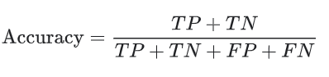**. . . . . . . . . . . . . . . (1.1)**

**1.6.3 Recall**

Recall is a measure of the completeness or coverage of a machine learning model. It is the ratio of the true positives to the total number of actual positive samples. In other words, it measures the percentage of correctly predicted positive samples among all the actual positive samples.

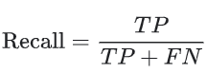 **. . . . . . . . . . . . . . . . . . (1.2)**

**1.6.4 Precision** Precision is a measure of the exactness or fidelity of a machine learning model. It is the ratio of the true positives to the total number of positive predictions made by the model. In other words, it measures the percentage of correctly predicted positive samples among all the predicted positive samples.

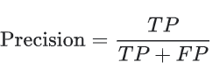**. . . . . . . . . . . . . . . . . . . . . . . . (1.3)**

**1.6.5 F1-Score**

F1-Score is defined as the harmonic mean of precision and recall, where precision measures the proportion of true positives among all positive predictions, and recall measures the proportion of true positives that were correctly identified.

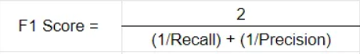 **. . . . . . . . . . . . . . . (1.4)**

**1.7 Organization of the report**

The report begins with a brief overview of the project, its scope of work and significance, a review of the literature, the problem statement, the problem objective, and the project's metrics. The second chapter describes the classification methods utilized in the project, including deep learning algorithms with transfer learning and machine learning classification algorithms. Other technologies like Docker, the Recent V50, and the Telegram bot are also covered. The third chapter discusses system design and implementation and includes sections on the architecture for prediction using the audio dataset, spiral dataset, and telegram, the architecture of the flask mailer, the software requirements, the APIs used, and other technologies like Python, VS Code, Flask, Google Collab, and many others.  Result snapshots and analysis are included in Chapter 4. Conclusion is given in Chapter 5 and scope for future work is given.

**Chapter 2**

**CLASSIFICATION TECHNIQUES**

For prediction of Parkinson diseases, four classification algorithms under machine learning were applied on speech dataset and Convolutional neural network under deep learning for spiral dataset. In this chapter detailed explanation is given regarding the same.

**2.1 Machine learning**

**Machine learning (ML) is a subset of Artificial Intelligence,** as the name says, is all about machines learning automatically without being explicitly programmed or learning without any direct human intervention. The process starts with feeding them good quality data and then training the machines by building various machine learning models using the data and different algorithms. It **enables the machine to automatically learn from data, improve performance from past experiences, and make predictions.** Machine learning can be divided into 3 types:

* **Supervised Learning:** A labelled dataset is used to train the algorithm in supervised learning. Regression and classification are the two major divisions. Supervised learning algorithms are extensively used in many different industries, including speech recognition, computer vision and many more.
* **Unsupervised learning:** A model must find patterns in a dataset without labels and with little to no human oversight. In unsupervised learning tasks, similar examples are usually grouped together, unsupervised learning doesn’t require any output variable in its data. Unsupervised learning discovers information by itself.
* **Reinforcement learning**: Reinforcement Learning is a feedback-based Machine learning technique in which an agent learns to behave in an environment by performing the actions and seeing the results of actions. For each good action, the agent gets positive feedback, and for each bad action, the agent gets negative feedback or penalty.

**2.2 Classification Algorithms**

The Classification algorithm is a Supervised Learning technique that is used to identify the category of new observations based on training data. In Classification, a program learns from the given dataset or observations and then classifies new observation into several classes or groups. Such as, **Yes or No, 0 or 1, Spam or Not Spam,** etc. Classes can be called as targets/labels or categories. It takes labelled input data, which means it contains input with the corresponding output. The main goal of the Classification algorithm is to identify the category of a given dataset, and these algorithms are mainly used to predict the output for the categorical data. Classification algorithms can be better understood using the below diagram. In Fig. 2.1, there are two classes, class A and Class B. These classes have features that are similar to each other and dissimilar to other classes.

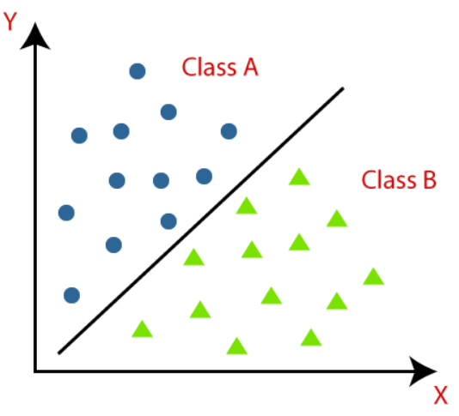

**Fig. 2.1 Classification**

The algorithm which implements the classification on a dataset is known as a classifier. Examples of classification algorithms are Naïve Bayes, Random Forest, and many more. In our project four classification algorithms were used, which are explained in the following sections.

**2.2.1** **K-Nearest Neighbor**

K-Nearest Neighbor (KNN) algorithm assumes the similarity between the new case/data and available cases and put the new case into the category that is most similar to the available categories. It stores all the available data and classifies a new data point based on the similarity. This means when new data appears then it can be easily classified into a well suite category by using K- NN algorithm. K-NN algorithm can be used for Regression as well as for Classification but mostly it is used for the Classification problems.

It is also called a **lazy learner algorithm** because it does not learn from the training set immediately instead it stores the dataset and at the time of classification, it performs an action on the dataset. KNN algorithm at the training phase just stores the dataset and when it gets new data, then it classifies that data into a category that is much similar to the new data. Fig. 2.2 shows the representation of KNN algorithm.

The K-NN working can be explained on the basis of the below algorithm:

* **Step-1:** Select the number K of the neighbors
* **Step-2:** Calculate the Euclidean distance of**K number of neighbors**
* **Step-3:** Take the K nearest neighbors as per the calculated Euclidean distance.
* **Step-4:** Among these k neighbors, count the number of the data points in each category.
* **Step-5:** Assign the new data points to that category for which the number of the neighbor is maximum.
* **Step-6:**  Model is ready.

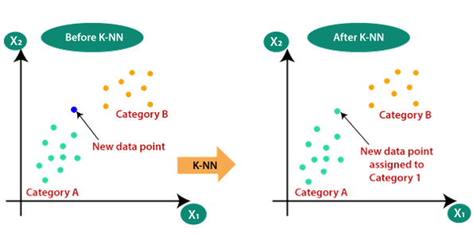

**Fig. 2.2 K-Nearest Neighbor**

**2.2.2 Decision Tree Classifier**

Decision Tree is a Supervised learning technique that can be used for both classification and Regression problems, but mostly it is preferred for solving Classification problems. It is a tree-structured classifier, where internal nodes represent the features of a dataset, branches represent the decision rules, and each leaf node represents the outcome as shown in Fig. 2.3.In a Decision tree, there are two nodes, which are the Decision Node and Leaf Node. Decision nodes are used to make any decision and have multiple branches, whereas Leaf nodes are the output of those decisions and do not contain any further branches.The decisions or the test are performed based on features of the given dataset. It is a graphical representation for getting all the possible solutions to a problem/decision based on given conditions. A decision tree simply asks a question and based on the answer (Yes/No), it further split the tree into subtrees.

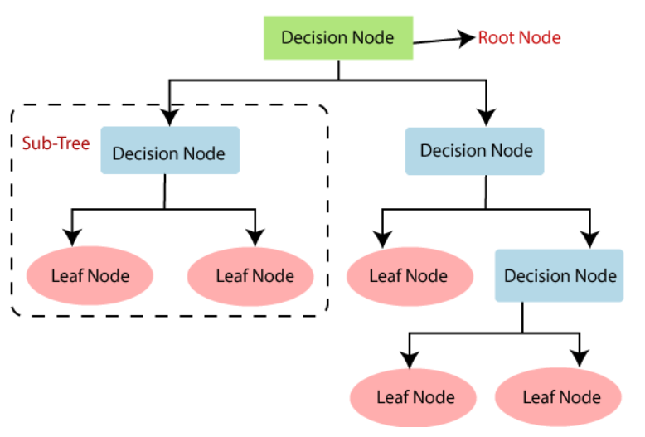

**Fig. 2.3 Decision Tree Classifier**

**2.2.3 Random Forest Classifier**

Random Forest can be used for both Classification and Regression problems in ML. It is based on the concept of **ensemble learning,** which is a process of combining multiple classifiers to solve a complex problem and to improve the performance of the model.

**"Random Forest is a classifier that contains a number of decision trees on various subsets of the given dataset and takes the average to improve the predictive accuracy of that dataset."** Instead of relying on one decision tree, the random forest takes the prediction from each tree and based on the majority votes of predictions, and it predicts the final output**. The greater number of trees in the forest leads to higher accuracy and prevents the problem of overfitting. Fig. 2.4 shows the working of random forest classifier.**

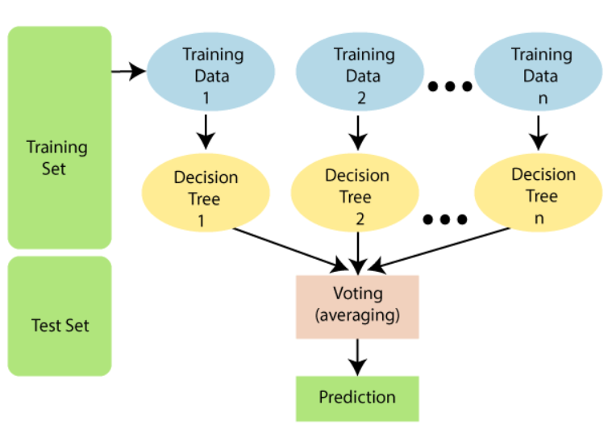

**Fig. 2.4 Random Forest Classifier**

* + 1. **XG Boost**

XGBoost is a powerful machine learning algorithm that is widely used in industry and academia for regression, classification, and ranking problems. It is a type of boosting algorithm that combines the predictions of multiple weak models, such as decision trees, to create a more accurate final prediction. The algorithm works by iteratively training a series of weak models, with each subsequent model attempting to correct the errors of the previous one which is shown in Fig. 2.5. The predictions of all the weak models are then combined to create a final prediction. The training process involves minimizing a loss function, such as mean squared error or cross-entropy, using gradient descent.

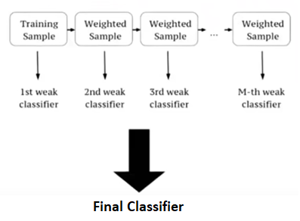

**Fig. 2.5 XG Boost Classifier**

XGBoost uses several advanced techniques to improve its performance, such as regularized learning, which prevents overfitting, and tree pruning, which helps to reduce the complexity of the model. It also incorporates features such as parallel processing and support for missing data, which make it highly efficient and flexible.

* Overfitting: Although XGBoost includes regularization techniques, it is still possible to overfit the model if the hyperparameters are not tuned properly.
* Complexity: XGBoost is a complex algorithm that requires a good understanding of its inner workings to use it effectively. It may not be suitable for beginners or for simple machine learning tasks.
* Interpretability: The black-box nature of XGBoost can make it difficult to interpret the model and to explain the results to non-experts. This can be a problem in some applications, such as those involving legal or ethical issues.

**2.3 Deep Learning**

Deep learning is a branch of machine learning which is completely based on artificial neural networks, and it mimics the human brain. In deep learning, we don’t need to explicitly program everything. These neural networks are inspired by the structure and function of the human brain, and they are designed to learn from large amounts of data in an unsupervised or semi-supervised manner.

Deep Learning models can automatically learn features from the data, which makes them well-suited for tasks such as image recognition, speech recognition, and natural language processing.

* + 1. **Convolutional Neural Networks**

A Convolutional Neural Network (CNN) is a type of deep learning algorithm that is particularly well-suited for image recognition and processing tasks. It is made up of multiple layers, including convolutional layers, pooling layers, and fully connected layers. The convolutional layers are the key component of a CNN, where filters are applied to the input image to extract features such as edges, textures, and shapes. The output of the convolutional layers is then passed through pooling layers, which are used to down-sample the feature maps, reducing the spatial dimensions while retaining the most important information. The output of the pooling layers is then passed through one or more fully connected layers, which are used to make a prediction or classify the image. The three above mentioned layers are shown in Fig. 2.6.

CNNs are trained using a large dataset of labelled images, where the network learns to recognize patterns and features that are associated with specific objects or classes. Once trained, a CNN can be used to classify new images, or extract features for use in other applications such as object detection or image segmentation.

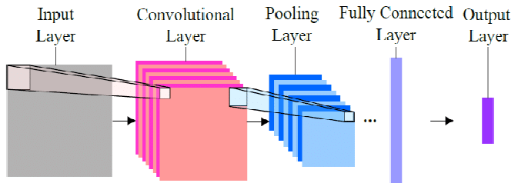

**Fig. 2.6 Layers in CNN**

**2.4 Transfer Learning**

Transfer learning is a technique used in machine learning where a pre-trained model is used as a starting point for training a new model on a different task or dataset. In transfer learning, the knowledge acquired by the pre-trained model during its training on a large and general dataset is transferred to the new task or dataset, allowing the new model to achieve better performance. In transfer learning, the pre-trained model is typically a deep neural network that has been trained on a large dataset, such as ImageNet, which contains millions of labelled images. The pre-trained model can be used as a feature extractor, where the learned features from the earlier layers are extracted and fed into a new model that is trained on a smaller dataset for a different task.

Transfer learning has become a popular technique in deep learning because it can save a lot of time and computational resources that would be required to train a new model from scratch. It has been successfully applied in various domains, including computer vision, natural language processing, and speech recognition. Many deep learning frameworks, such as TensorFlow, PyTorch, and Keras, provide pre-trained models that can be used for transfer learning.

Some of the popular pre-trained models are VGG (Visual Geometry Group), ResNet (Residual Network), Inception, MobileNet and DenseNet.

**2.5 ResNet (Residual Network)**

A deep neural network architecture developed by researchers at Microsoft. ResNet uses skip connections to address the vanishing gradient problem and has achieved state-of-the-art performance on many computer vision tasks. ResNet architectures have been very successful in image recognition tasks, such as the ImageNet challenge, where they have achieved state-of-the-art performance.

The original ResNet architecture includes different variations with different numbers of layers, such as ResNet-18, ResNet-34, ResNet-50, ResNet-101, and ResNet-152, which have different numbers of layers and varying depths. ResNets and their variants can be implemented using deep learning frameworks such as PyTorch, TensorFlow, and Keras.

**2.5.1 ResNet v1 50 model architecture**

ResNet-50 is a deep neural network architecture that was introduced in 2015 by Microsoft researchers He et al. It is part of the ResNet family of architectures, which were developed to address the problem of vanishing gradients in deep neural networks. ResNet-50 is composed of 50 layers, hence the name. The architecture is based on residual learning, which involves learning the residual (or difference) between the input and the output of a layer. This approach allows for the construction of much deeper neural networks while avoiding the problem of vanishing gradients.

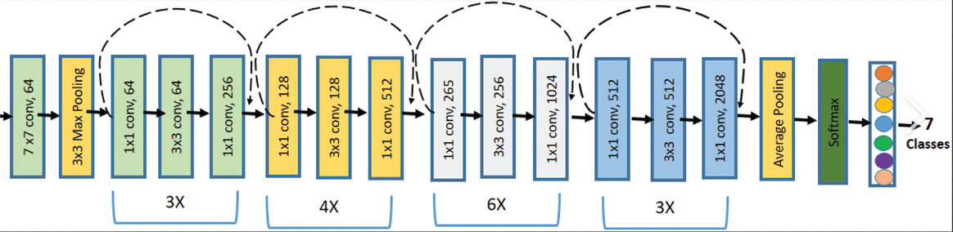

INPUT FRAMES

PREDICTED SUBJECT

**Fig. 2.7 Architecture of ResNet V150**

The ResNet-50 architecture shown in Fig. 2.7 consists of the following layers:

1. **Input layer:** The input to the network is a 224x224 RGB image.
2. **Convolutional layers:** The first layer is a convolutional layer with 64 filters, followed by three stages of convolutional layers, each stage consisting of three convolutional layers with 64, 128, and 256 filters, respectively.
3. **Shortcut connections:** In each stage, there is a shortcut connection that bypasses one or more convolutional layers. This allows for the residual learning approach and helps to avoid vanishing gradients.
4. **Global average pooling:** After the convolutional layers, the output is fed into a global average pooling layer, which computes the average of each feature map across its spatial dimensions.
5. **Fully connected layers:** The global average pooling layer is followed by two fully connected layers with 1,000 units each, which correspond to the number of classes in the ImageNet dataset.
6. **Softmax activation:** The final layer is a softmax activation layer that outputs a probability distribution over the 1,000 classes.

**2.6 Data Augmentation**

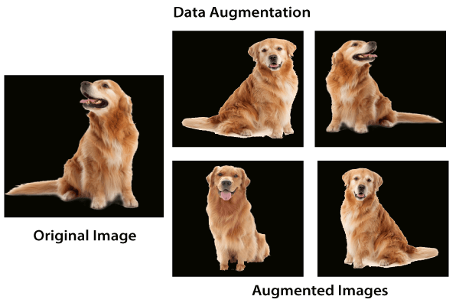

**Fig. 2.8 Data Augmentation**

Data augmentation is a popular technique in machine learning and deep learning, as it can help to improve the performance of models by increasing the diversity and size of the training data. Transformations such as rotating, scaling, flipping, cropping, or adding noise can be used to create new examples of the data (shown in Fig. 2.8) that are similar to the original examples but different enough to provide additionalinformation to the model. It can be applied tovarious types of data, such as images, audio, text, and time-series data, and can be implemented using libraries like Keras ImageDataGenerator or OpenCV.

**2.7 Telegram Bot**

Its user-friendly interface and security features have helped Telegram become a well-known messaging software. The support for bots—automated programs that can carry out a variety of tasks inside the app is one of Telegram's most distinctive features Users can add images, audio, and video through Telegram bots, which communicate with users using JSON-encapsulated text messages and inline buttons. The bot application that is operating on the server could be anything, including a chat application, a search engine, a huge multimedia library, or a problem-solving machine. The bot can be used by users to perform functions like teaching, playing, searching, broadcasting, recalling, connecting, integrating with other services, and sending instructions.

Telegram bots can host whole JavaScript-built web applications. This makes it possible to create interfaces that are infinitely customizable and can power everything from online shops to arcade games. In contrast to websites, bots automatically offer smooth authorization and alerts using Telegram. Bots are little programmes that are only accessible through the Telegram app. Flexible user interfaces that can support any job or service are used for user interaction with bots.

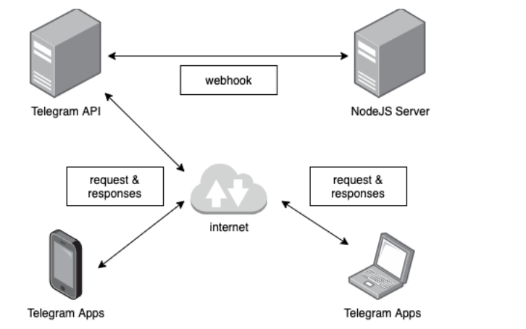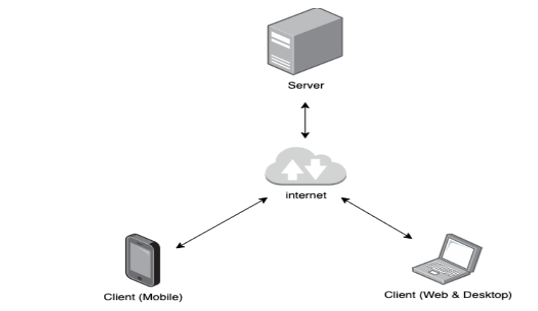**2.7.1 Architecture for Telegram Bot**

**Fig. 2.9 Architecture of Telegram Bot**

Service-oriented architecture is the extension of client-server architecture where the server acts as a data center that provides access services in the form of services or better known as Application Programming Interface (API). All data should be centrally located on a server if we want to design software that can be used on multiple platforms, such as instant messaging applications that can be used on mobile devices and desktops. In that case, the most appropriate form of architecture to implement is service-oriented architecture. The main advantage of implementing a service-oriented architecture is that it allows developers to design apps for many platforms using only one data center server, so it will greatly save time and cost in developing applications. Architecture of telegram bot is show in Fig. 2.9

Webhook is a web-based application development paradigm, where the web application will be triggered when there is a desired event. As in the example shown in Fig. 2.9 a webhook is a mechanism through which a server (Telegram API) will call service on another server (Custom NodeJS server) when it receives a certain request from the client. In the figure the Telegram API server is in charge of processing client chat sessions and delivering client requests to the NodeJS-based chatbot server; hence, each server has its responsibility to ensure that it is not overloaded.

**2.8 Docker**

Docker is a popular platform for building, deploying, and running applications using container technology. It allows developers to package an application and its dependencies into a single unit called a container, which can be run consistently across different environments. Docker images are the building blocks for creating containers. They are essentially snapshots of an application's environment, including its code, dependencies, and configuration. Docker images are typically created using a Dockerfile, which is a script that specifies the steps needed to build the image.

Containers are lightweight, portable, and isolated environments that can be run on any platform that supports Docker. Each container is an instance of a Docker image, and it contains all the necessary components to run the application, including the application code, libraries, and configuration. Volumes in Docker are a way to persist data outside of a container. They are typically used to store data that needs to be shared between containers or to store data that should survive container restarts or deletions. Volumes can be created and managed using Docker commands or through the Docker API. They can be mounted to specific directories within a container, allowing applications to read and write data to those directories as if they were on the host machine.

**Docker Compose:** Docker Compose is a tool for defining and running multi-container Docker applications. It allows developers to define an application’s services, networks, and volumes in a single YAML file, which can be used to create and start all the necessary containers for the application to run.With Docker Compose, developers can define multiple services that are required to run an application, such as a web server, a database, and a cache server, all in a single file. The YAML file can specify each service’s Docker image, ports, volumes, and environment variables, among other things.

When Docker Compose is run, it reads the YAML file and creates all the necessary Docker containers, networks, and volumes, and connects them together as specified in the file. Developers can then use the Docker Compose CLI to start, stop, and manage the containers and the application. Docker Compose makes it easier to manage complex multi-container applications by providing a simple and consistent way to define and start them. It also enables developers to easily move their applications between different environments, such as from development to production, by simply using the same YAML file to create the containers in each environment.

**2.9 Summary**

In this chapter, various algorithms used in prediction of Parkinson disease are discussed which includes KNN, decision tree, random forest, XG Boost and CNN algorithm. Transfer learning was discussed and a popular transfer learning model that is ResNet 50. Also, data augmentation, telegram bot with its architecture and docker are explained.

**Chapter 3**

**SYSTEM DESIGN AND IMPLEMENTATION OF PARKINSON’S DISEASE DETECTION SYSTEM**

This section consists of a detailed explanation on the models implemented along with their system designs. The implementation process along with the software requirements is put forward in this chapter.

**3.1 System design**

Two different models were implemented for the prediction of Parkinson disease. Audio dataset was employed to train various classification machine learning algorithms. The spiral drawings dataset was employed to train CNN algorithm. System design for both the models are covered in section 3.1.1 and 3.1.2. Also, a chat bot facility is provided, whose architecture and working are discussed in section 3.1.3.

**3.1.1 Architecture for prediction Parkinson’s using audio data**

System design for the model trained using audio dataset is shown in Fig. 3.1. The stages followed in project to predict the Parkinson’s disease using voice dataset:

1. **Collecting the data**

The data set is obtained from UCI machine learning repository, that is “Parkinson Data Set”. The data set contains 23 columns and 195 entries of data, the data present consists of vocal measurements like frequency, jitters and many more. https://archive.ics.uci.edu/ml/datasets/Parkinsons

1. **Cleaning and transforming the data.**

The obtained data is pre-processed and scaled using standardization and normalisation techniques. Standardization is applied while training the model on Random Forest algorithm and normalization is applied for XG Boost. Also, the ‘name’ attribute is dropped from the dataset as it is of no significance.

1. **Splitting the data**

On completion of the above step the data is split into test and train in the ratio 8:2. Different splits were performed and analysed which is discussed in chapter 4. But the performance of the model was better when it was split in 8:2.

1. **Fitting the model**

The training data and the algorithms are fit together. Four Machine learning algorithms are implemented which are K Nearest Neighbor, Decision Tree, Random Forest and XGBoost.

The parameters chosen for these four algorithms are as follows:

K Nearest Neighbor: Number of neighbours random state value is also set to 5.

Decision tree: Random state value is set to 42.

Random forest: Random state value is set to 42 and n_estimators is set to 200.

XG Boost: Random state is set to 42.

Random state value ensures that same results are generated every time. If this is not set, then each time different split will be produced. Here the n_estimators in random forest denotes the number of decision trees to be implemented.

1. **Evaluation**

The trained model is then evaluated based on testing dataset. Evaluation metrices is chosen consisting of all the four accuracy, F1-score, Recall and Precision score to analyse the performance of various ML algorithms which were implemented in the previous step.

1. **Prediction**

Finally, four predictions are obtained from four models. Based on this prediction an analysis is made and a result is given which can either be “Person has Parkinson’s disease” or “Person is likely to have Parkinson’s disease” or “Person does not have Parkinson’s disease”.

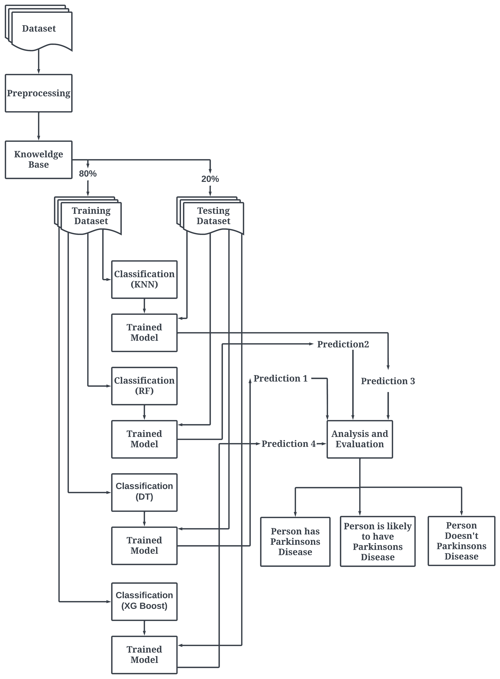

**Fig. 3.1 Architecture for prediction using audio data**

**3.1.2 Architecture for prediction using spiral data**

The architecture for the model trained using spiral dataset is given in Fig. 3.2. A Convolutional neural network by making use of transfer learning is implemented.

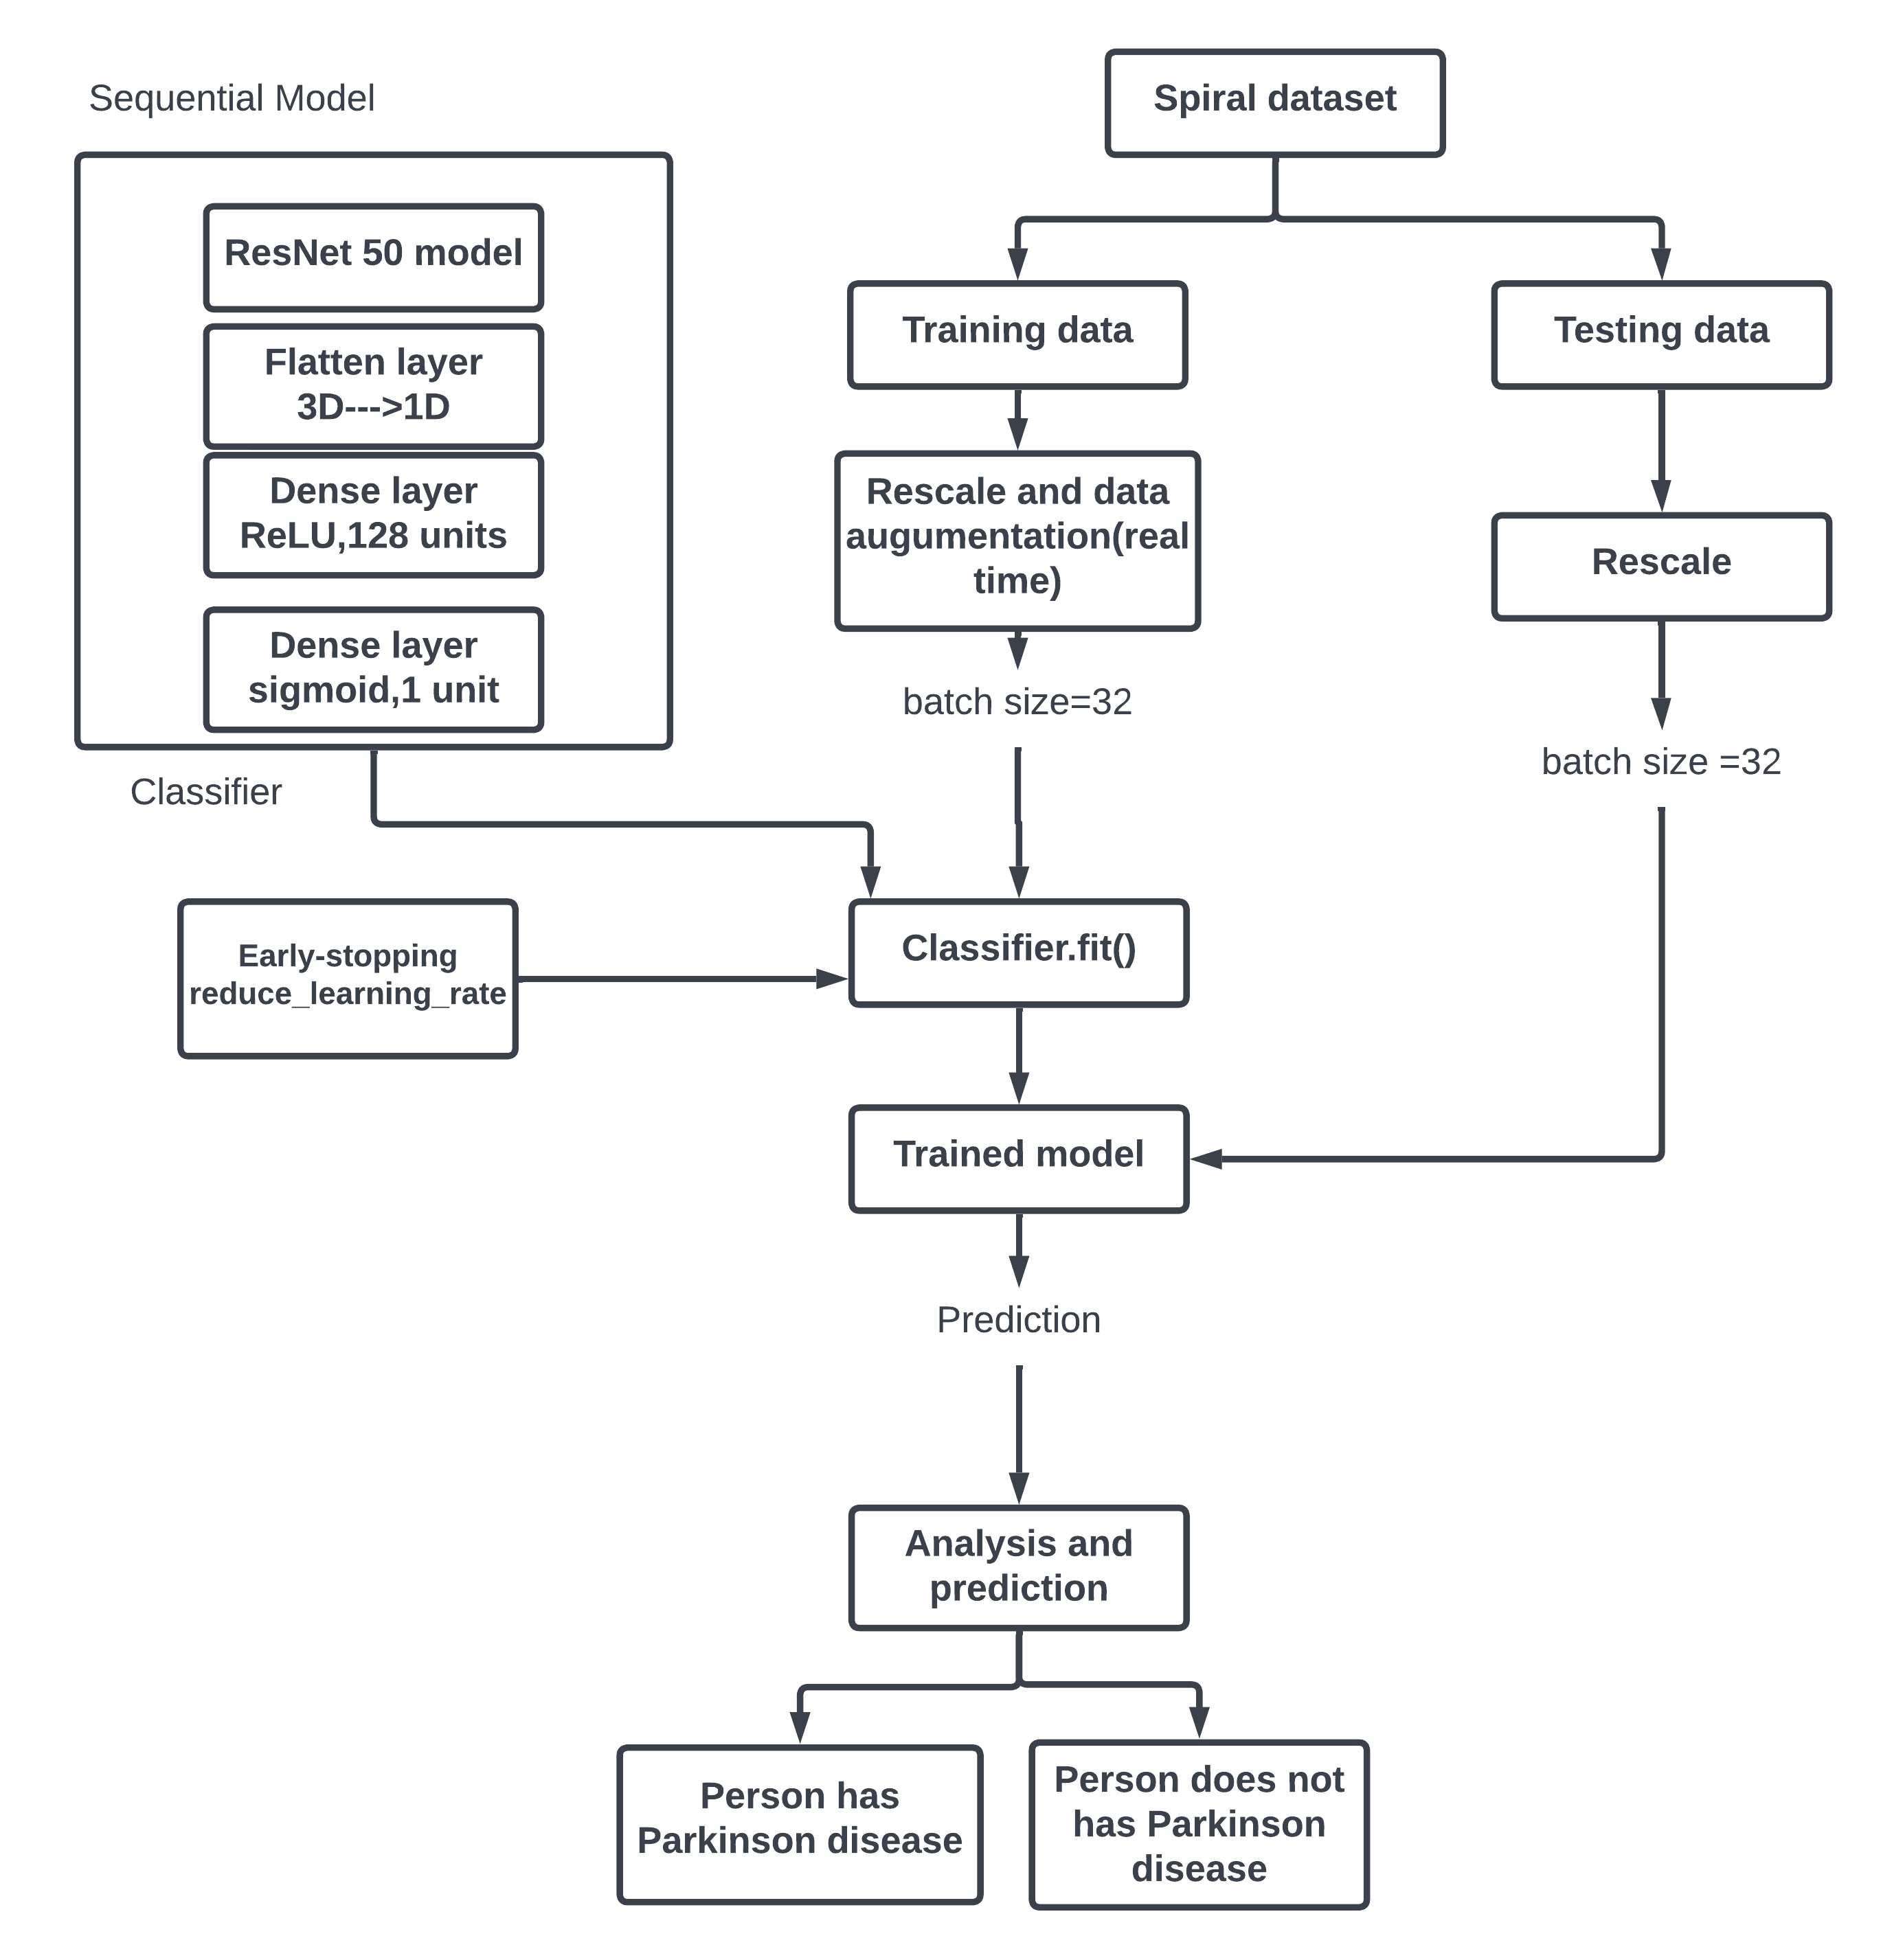

**Fig. 3.2 Architecture for prediction using spiral data**

Following are the stages of project to predict the Parkinson’s disease using spiral dataset:

1. **Collecting the data**

The data set is obtained from Kaggle, that is “Parkinson’s Drawings”. The dataset contains images of healthy and patients with Parkinson’s spiral drawings. The images are further divided into training and testing. https://www.kaggle.com/datasets/kmader/parkinsons-drawings.

1. **Splitting the data**

The acquired dataset is already split into train and test data for both healthy and PD (Parkinson’s Disease) affected people. The training data has 72 spiral images, and the testing data has 30 spiral images.

1. **Defining a sequential model**

A sequential model called classifier is defined to which the ResNet 50 model is added. The ResNet model is only used for feature extraction that is the fully connected layers are not included. This model is initialized with pre-trained weights of imagenet dataset and the output of this model will be learned features of input layers.

This is followed by a flatten layer which is used to flatten the output of feature maps generated by ResNet model into 1D array. That is the 3D tensor output of ResNet model will be converted to 1D array of features. This is done because fully connected layer requires a 1D input tensor and it reduces complexity.

This layer is followed by two dense layers, where the first layer has Rectified linear unit (ReLU) as the activation function, and it consists of 128 units. And the second dense layer has the sigmoid activation function with 1 unit.

1. **Data augmentation**

Real time data augmentation is performed only on training data. Images are read from directory and batches of augmented images are generated where the batch size is specified be 32. Rescaling is done on both training and testing data to be between 0 and 1 by dividing them by 255 (rescale=1./255). Augmentation techniques like shear range and zoom range are applied by the factor 0.2 where the images are zoomed and tilted at an angle.

1. **Fitting the model**

The sequential classifier and the training data are fit together. Along with this two-callback function are defined. Early stopping is a callback function which is used to stop the training process of neural network when the monitor metric stops improving. This helps reduce the risk of overfitting. Reduce learning rate is another callback function which reduces the learning rate when the monitored metric stops improving. The factor by which the learning rate is reduced is 0.2. And the monitored metric in both the callback function is loss value.

trained model is then evaluated based on testing dataset.

1. **Evaluation**

Trained model is then evaluated based on testing dataset. Finally, the accuracy scores of every iteration in CNN Algorithm was noted and prediction was made based on the drawing for the presence or absence of the Parkinson disease.

**3.1.3 Architecture for telegram bot**

For the user who are not familiar with using the website, a user-friendly telegram chat bot facility is made available. Fig. 3.3 shows the working architecture of telegram chat bot.

**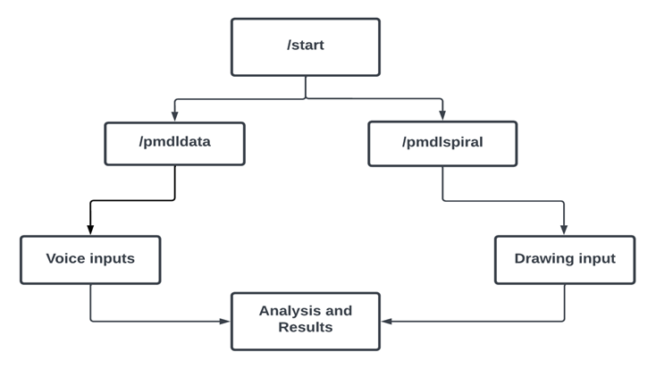  
Fig. 3.3 Architecture for prediction using telegram bot**

1. ‘/start’ command is entered to initiate a chat with the bot
2. Two options are provided that is ‘/pmdldata’ and ‘/pmdlspiral.
3. ‘/pmdldata’ is for prediction if Parkinson using speech data, where the user has to enter the data and prediction will be done based on machine learning algorithms. Here prediction is done using the same architecture discussed in section 3.1.1.
4. ‘/pmdlspiral’ is for prediction if Parkinson using spiral data, where the user has to provide image as an input and a prediction will be made. Here prediction is done using the same architecture discussed in section 3.1.2.

**3.2 Flask mailer**

One of the most basic functions in a web application is the ability to send emails to your users. Flask Mailer is a Flask extension that provides an easy way to send emails from your Flask application. It simplifies the process of configuring and sending emails using SMTP servers or other email providers. With Flask Mailer, you can send plain text, HTML, and multi-part emails with attachments. It supports several email providers such as SMTP, Gmail, Yahoo, and others.

Name, Email id and data features/spiral image are collected from user in the frontend using POST method. After retrieving the data prediction is performed using multiple algorithms. Upon completion of prediction process, the results are sent to the mail id of users. The flask server is configured using several attributes such as :

***os.environ[‘API_USER’]=’mail@xyz.com’***

***os.environ[‘AP I_PASSWORD’]=’app password’***

And to instantiate the mail server the following configurations are set

**app.config[“…………”]**

**“MAIL_SERVER" = 'smtp.gmail.com'**

Sets the email server to use Gmail’s SMTP server for sending mails.

"**MAIL_PORT" = 465**

Sets the port to use for the SMTP server. In this case, port 465 is used, which is the SSL-encrypted port for SMTP.

"**MAIL_USE_SSL = True**

Enables SSL encryption for the SMTP connection.

**"MAIL_USERNAME" = os.environ.get('API_USER')**

Sets the username to use when authenticating with the SMTP server. The username is read from an environment variable named "API_USER" using the os.environ.get method.

**"MAIL_PASSWORD" = os.environ.get('API_PASSWORD')**

Sets the password to use when authenticating with the SMTP server. The password is read from an environment variable named "API_PASSWORD" using the os.environ.get method.

With these configuration parameters set, the Flask application can use the flask_mail library to send emails using the specified Gmail account. Subject is included in the email along with that email id and the name of the user is being appended along with a body which contains the information regarding if the person has the Parkinson disease or does not have Parkinson disease.

**3.2.1 Architecture of Flask Mailer**

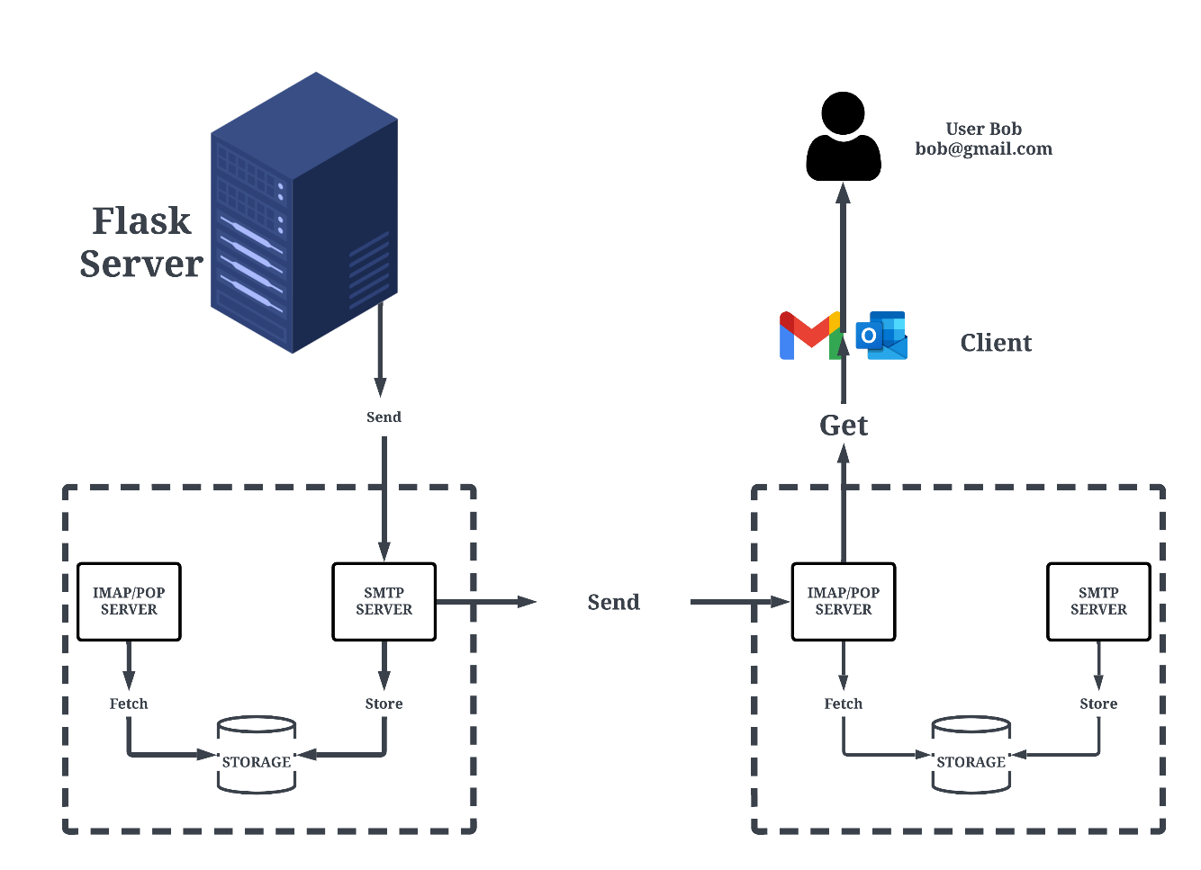

**Fig. 3.4 Architecture of Flask mailer**

The architecture of Flask Mailer involves three main components:

1. **Flask application:** The Flask application is the main component of your application, which handles the request/response cycle and other aspects of your application's functionality.
2. **Mailer object:** The Mailer object is created and registered with the Flask application as an extension. This object provides the send method, which is used to send emails.
3. **Message object:** The Message object represents the email message you want to send. It contains the subject, body, recipients, and other details about the email.

When you create a Message object and pass it to the send method of the Mailer object, Flask Mailer uses the configuration settings you provided to send the email. Flask Mailer simplifies the process of sending emails from your Flask application by providing an easy-to-use interface and supporting different email providers.

**3.3 APIs Used**

APIs used along with their descriptions are given in Table. 3.1.

**Table. 3.1 APIs used**

|  |  |
| --- | --- |
| **APIs** | **Description** |
| GET api/tutorials get all tutorials | In Frontend GET method is used to send a get request to a server. In Backend GET method is used to retrieve the features which we have used in our data. |
| POST api/tutorials add new tutorial | In Frontend POST method is used by HTTP to submit dataset features to a web server. In Backend is used to create or update resources on a server |

**3.4 Software Requirements**

A brief explanation on the software’s used in this project is covered in this section.

**3.4.1 Python**

Python was the language of selection for this project. This was a straightforward call for many reasons.

1. Python as a language has a vast community behind it. Any problems which may be faced is simply resolved with a visit to Stack Overflow. Python is among the foremost standard language on the positioning that makes it very likely there will be straight answer to any question.
2. Python has an abundance of powerful tools prepared for scientific computing Packages like NumPy, Pandas and SciPy area unit freely available and well documented. Packages like these will dramatically scale back, and change the code required to write a given program. This makes iteration fast.
3. Python as a language is forgiving and permits for program that appear as if pseudo code. This can be helpful once pseudo code given in tutorial papers must be enforced and tested.

**3.4.2 VS Code**

Visual Studio Code, also commonly referred to as VS Code, is a source-code editor made by Microsoft with the Electron Framework, for Windows, Linux and macOS. It is a lightweight IDE which includes support for debugging, syntax highlighting, intelligent code completion and many other features. This IDE was use in this project as it is easy to use, has a good interface, a easily manageable file structure and contains a large variety of extensions. It also has an inbuilt command prompt, terminal and PowerShell which saves a lot of time and work.

**3.4.3 Flask**

Flask is a popular web framework for Python that is used to build web applications. It provides a lightweight and flexible way to create web applications that can be used to build small and large-scale web projects. Reasons why flask was used in this project is its flexible, lightweight, scalable, and easy to learn.

**3.4.4 Google Collab**

Google Colaboratory (also known as Google Colab) is a cloud-based service provided by Google that allows users to write and run Python code in a web browser, with no setup or installation required. Google colab was used in the implementation of project as it provides free access to a high-end GPU, which makes it an ideal platform for machine learning and data analysis tasks. Also, users can write code, execute it, and view the results in real-time, and can also collaborate with others by sharing their notebooks with them. Machine learning algorithms were implemented on colab by making use of the libraries such as sklearn, pandas and many more. Dataset was imported, split for training-testing and algorithms were applied to train the model. All for four models were trained on different notebooks and converted to sav files for future predictions.

**3.4.5 Numpy**

NumPy is a Python library that is used for scientific computing and data analysis. It stands for "Numerical Python".

NumPy provides a powerful N-dimensional array object, as well as functions for manipulating and performing operations on these arrays. ‘expand_dims()’ is a function provided by the NumPy library in Python that is used to add a new axis to an existing NumPy array. The input spiral image collected from the user is converted into an array. ‘expand_dims()’ is used to add a new dimension to the image array a with a length of 1, effectively creating a new 3D array with shape for grayscale images or for color images. This new array can then be passed as input to a machine learning model that expects a 4D input tensor with a batch size of 1.

**3.4.6 Pandas**

Pandas is a Python library that provides data manipulation and analysis tools. It is built on top of the NumPy package and provides a fast and efficient way to work with structured data such as tabular data. The key data structures provided by Pandas are Series and Data Frame. Pandas is commonly used for reading comma separated value (CSV) file. CSV files can be read using the ‘read_csv()’ function provided by the pandas library in Python. This function that takes a file path as an argument and returns a pandas Data Frame object that contains the data from the CSV file.

**3.4.7 Matplotlib**

Matplotlib is a popular data visualization library for Python. It provides a wide range of tools for creating high-quality plots, graphs, and charts to represent data in a visual format. Matplotlib can be used to create a variety of visualizations, including line plots, scatter plots, high level of customization for visualizations, allowing users to control the appearance of visual elements such as colors, labels, markers, and fonts. ‘plt’ is an alias for the matplotlib.pyplot module, which contains functions for creating and customizing plots. The xlabel(), ylabel(), and title() functions are used to add labels to the axes and a title to the plot. Finally, the show() function is called to display the plot. This library was used to plot confusion matrix and to check nulls values by plotting heatmap.

**3.4.8 Sklearn**

Scikit-learn, also known as sklearn, is a popular open-source machine learning library for Python. It provides a wide range of tools and algorithms for tasks such as data preprocessing, model selection, model evaluation, and more. Several classes from ‘Sklearn’ library are imported in our project which include ‘StandardScalar’ for preprocessing, ‘test_train_split’ which is used to split the datasret, ‘accuracy_score’, ‘recall_score’, ‘precision_score’ and ‘f1_score’ for evaluating the performance of the model. Also, various classifiers are also imported.

**3.4.9 XGBoost**

The xgboost module is a Python implementation of the XGBoost library, which is designed for efficient and scalable gradient boosting. ‘XGBClassifier’ is imported from the XGBoost library. XGBClassifier is an implementation of the gradient boosting algorithm which is designed to work with both classification and regression problems. It is an extension of the popular GradientBoostingClassifier from the sklearn library, with the addition of some extra features and optimizations, such as parallel computing, regularization, and handling missing values.

**3.4.10 H5**

The .h5 file format is a file format used for storing and exchanging large amounts of data in a structured way. The .h5 file format is based on the Hierarchical Data Format (HDF5), this allows users to store large multidimensional arrays, tables, and other complex data structures in a hierarchical format. In the context of machine learning, the .h5 format is often used to store trained models, which can then be loaded and used for making predictions on new data. The models are typically saved in a hierarchical structure, with layers and weights stored in separate groups within the file. The .h5 file format is supported by a variety of programming languages and python in one of them. In this project the CNN model trained on spiral dataset is saved in .h5 file format. Finally, this file is loaded using load_model() function which will be used for making prediction on the new data.

**3.4.11 Sav**

The ‘sav extension is not a standard file format in Python or in machine learning. However, it is commonly used to indicate that a file contains a serialized version of a trained model or data, which can be easily loaded and used in other programs or by other developers. In this project, .sav extension is used in conjunction with the pickle module in Python, which allows Python objects to be serialized and deserialized. By convention, the .sav extension is often used to indicate that a file contains a serialized version of a Python object created using the pickle module. All the trained models are converted to a file with a .sav extension contains the weights and parameters of a trained machine learning model, which can be easily loaded and used for making predictions on new data without having to retrain the model from scratch.

**3.4.12 TensorFlow**

TensorFlow is an open-source library for machine learning and artificial intelligence. TensorFlow supports a wide range of neural network architectures, including convolutional neural networks, recurrent neural networks, and generative models. It is used to import pre-trained ResNet50 model from ‘tensorflow.keras.applications’ module, which is a collection of popular pre-trained deep learning models that can be used for transfer learning.

**3.4.13 Keras**

Keras is a high-level neural network API written in Python that can run on top of different deep learning frameworks such as TensorFlow, Theano, and Microsoft Cognitive Toolkit. Keras provides a user-friendly interface to build different types of neural networks such as convolutional neural networks. Several classes were imported from Keras library wich include ‘Sequential’ class from the ‘keras.module’ module which isused to define a sequential module, ‘Dense’ class from ‘keras.layers’ module which is used to define a fully connected layer, ‘EarlyStopping’ and ‘ReduceLROnPlateau’ classes from the ‘keras.callbacks’ module that are used to define callback functions that can be called during the training of a neural network, ‘ImageDataGenerator’ is a class from the ‘keras.preprocessing.image’ module that is used to generate batches of augmented image data for training neural networks and many more.

**3.4.14 Pickle**

The pickle module in Python is used for serialization and deserialization of Python objects. Serialization refers to the process of converting a Python object into a byte stream, which can be saved to a file or transmitted over a network. Deserialization refers to the process of reconstructing the original Python object from the byte stream. In this project the pickle module is used to save a trained classifier to a file called 'classifier.sav' using the pickle.dump() method. This saves the serialized version of the object to the file, which can be loaded later using the pickle.load() method. The open() function is used to open the file in binary mode ('wb' for writing or 'rb' for reading binary data). The dump() method then writes the serialized version of the object to the file, which can be later loaded using the load() method. Therefore, the pickle module is used here to save a trained model to a file for later use, allowing you to save time and computational resources by not having to retrain the model every time you want to use it. Fig.3.5 shows how pickling works.

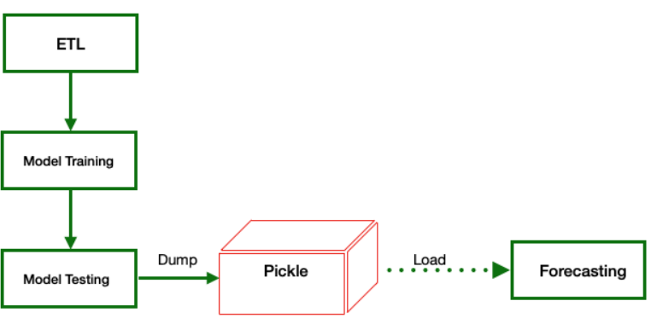

**Model Training**

**Pickle**

**Load**

**Dump**

**Pre-Processed** **data**

**Forecasting**

**Model Testing**



**Fig 3.5 Pickling**

**3.4.15 JavaScript**

JavaScript is a programming language that is used to create interactive web pages and web applications. It is a high-level, interpreted language that is primarily used on the client-side of web development, but it can also be used on the server-side with frameworks such as Node.js. JavaScript is commonly used to add interactivity to web pages, such as form validation, animations, and dynamic content updates.

JavaScript is often used in conjunction with other web development technologies such as HTML and CSS to create dynamic and engaging user interfaces. It can be used to manipulate the Document Object Model (DOM), which represents the structure of a web page in the browser, and to make asynchronous requests to servers to retrieve or update data without requiring a page refresh. JavaScript is a versatile language with a wide range of features, including object-oriented programming, functional programming, and event-driven programming. It has a large number of libraries and frameworks available, such as jQuery, React, and Angular, that make it easier to develop complex web applications.

**3.4.16 Bootstrap**

Bootstrap is a popular front-end framework used for building responsive and mobile-first web applications. Bootstrap provides a set of pre-built HTML, CSS, and JavaScript components, such as forms, buttons, navigation bars, and modals, that can be easily customized and used in web applications. In our project Bootstrap grid system was used to ensure consistent layout and alignment of content across all pages of the web application. In addition, Bootstrap's pre-built components, such as buttons, forms, and navigation menus, were customized and integrated into the application to provide a cohesive and user-friendly experience for end-users.

**3.4.17 HTML/ CSS**

HTML (Hypertext Markup Language) and CSS (Cascading Style Sheets) are two separate languages that are used together to create web pages and web applications. CSS is a style sheet language used to describe the presentation of a web page, including its layout, colors, fonts, and other visual elements The website was created using HTML and CSS to structure and style the content. HTML was used to organize the information into logical sections, such as headings, paragraphs, and lists. CSS was used to add visual elements to the report, such as colors, fonts, and background images. By using these technologies, the report was presented in a professional and visually appealing manner. Additionally, if any visual aids such as tables or images were included in the report, HTML and CSS would have been utilized to format and display them correctly. Overall, HTML and CSS played an important role in creating a well-structured and aesthetically pleasing website.

**3.5 Summary**

In this chapter, architecture for predicting Parkinson’s disease using audio, spiral data are given. The architecture for telegram bot is also given and explained. The architecture of flask mailer is explained. The APIs used, and software requirements were briefed.

**Chapter 4**

**RESULTS ANALYSIS AND DISCUSSION**

After developing models for both voice dataset and spiral drawing dataset, the final work was to build a simple User Interface for the user to interact with the Machine Learning Models. A simple and user-friendly web-application was developed by making use of Bootstrap framework, JavaScript, HTML and CSS.

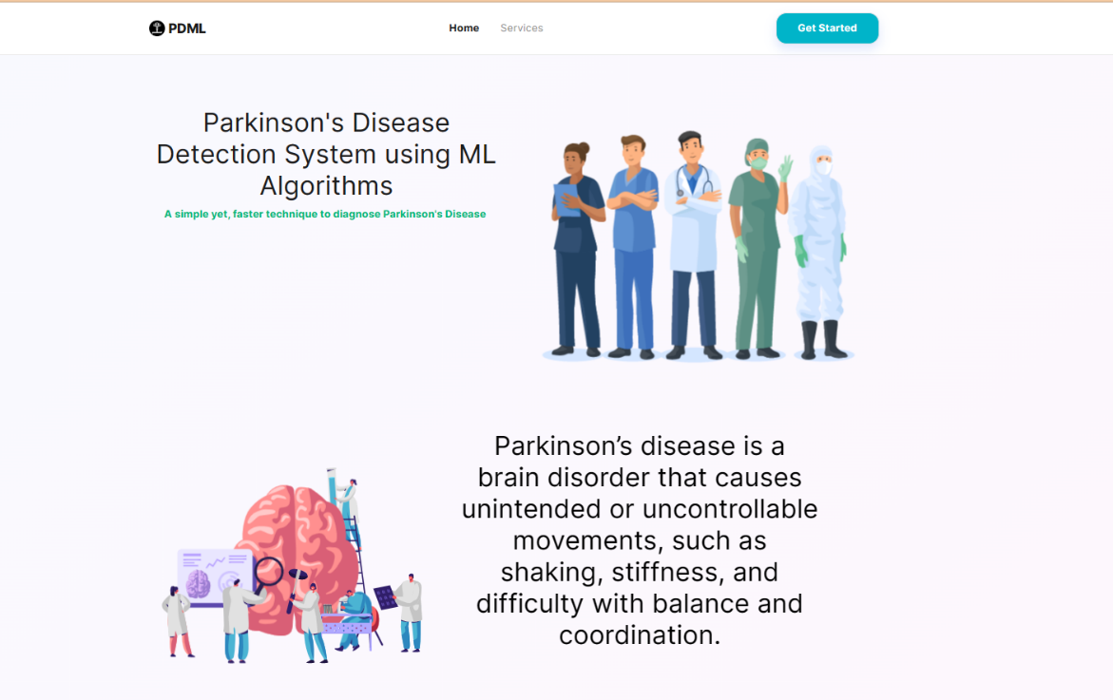

**Fig. 4.1 Home page view-1**

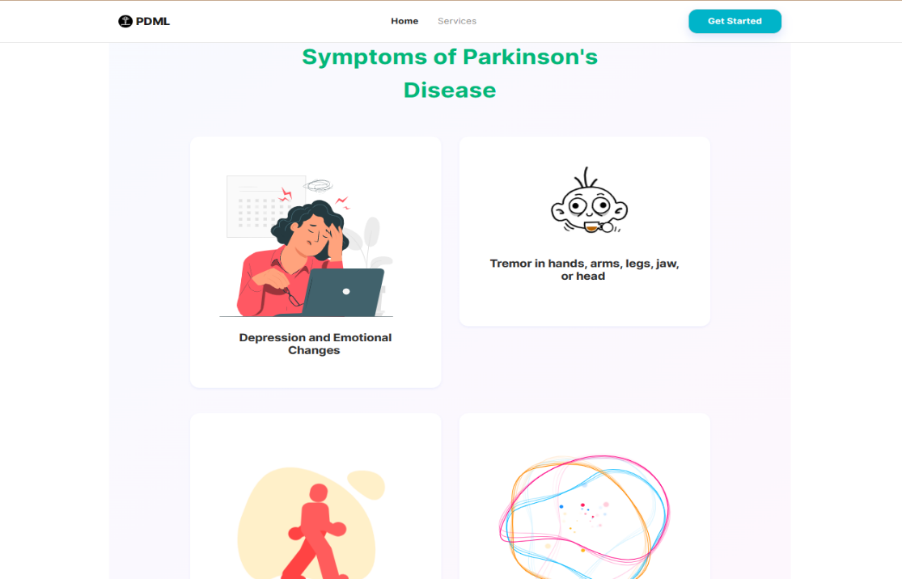

**Fig. 4.2 Home page view-2**

Fig. 4.1 and 4.2 shows the home page of the web application. The application includes basic information about Parkinson disease, symptoms of the diseases and services provided by the application . User queries, remarks or feedback are collected through phone number, email or a message as shown in Fig. 4.3.

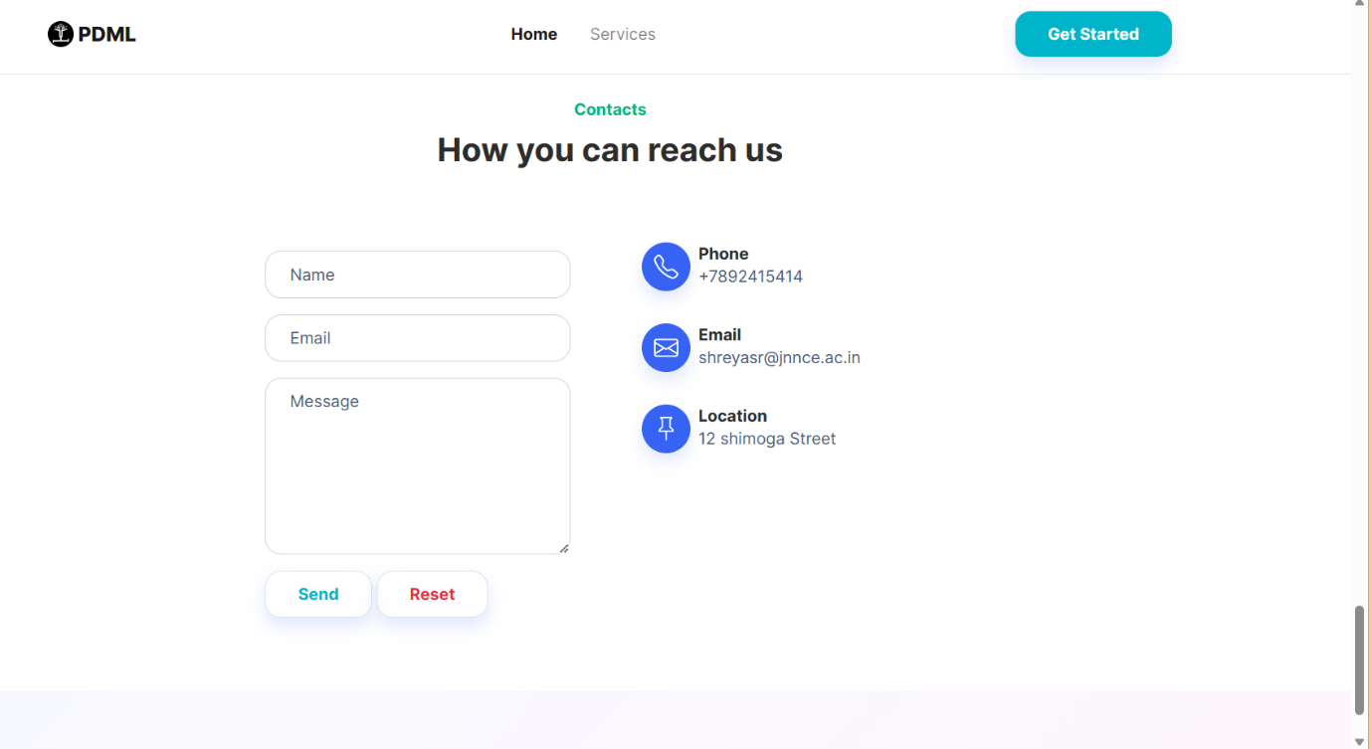

**Fig. 4.3 Home page view-3**

To precede with the predictions, click on the “Get Started” button on the top right corner, which will lead to next page. Here, a detailed view of the services provides are displayed. Services are provided in three folds, which are:

1. Prediction using audio features with highly accurate machine learning algorithms.
2. Prediction using spiral drawing with deep learning algorithm that is CNN.
3. A telegram chat bot facility

Detailed working of these services is discussed in the following sections.

**4.1 Prediction using audio features.**

Here, prediction of Parkinson’s is done using different voice features which include various frequency measure. The get started button on home page directs the user to the next page where the various services provided by us are displayed. Out of which the first one is prediction using vocal features which is shown in Fig.4.4.

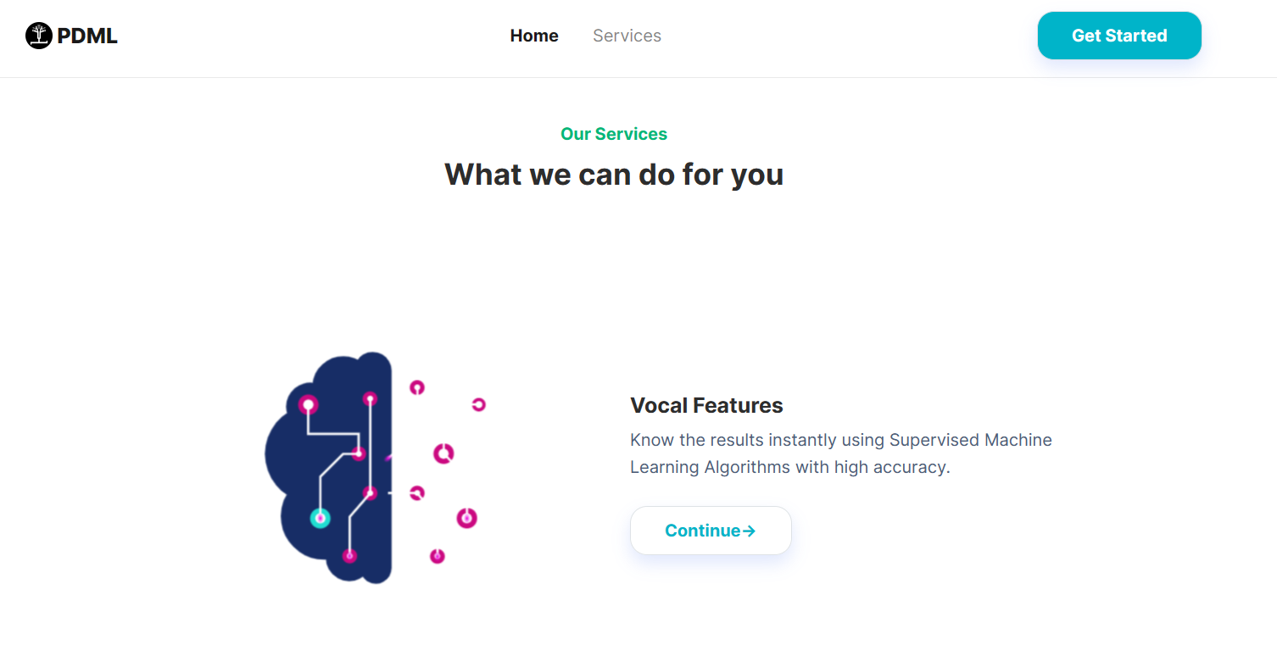

**Fig. 4.4 Prediction using vocal feature.**

On Clicking the “continue” button, the next page is displayed as shown in Fig. 4.5. Here the user must enter the details such as name and email id. These fields are mandatory to proceed further because once the prediction is complete, the results (i.e., the report) will be sent to the user’s mail. Once this is completed click on “continue” to proceed further.

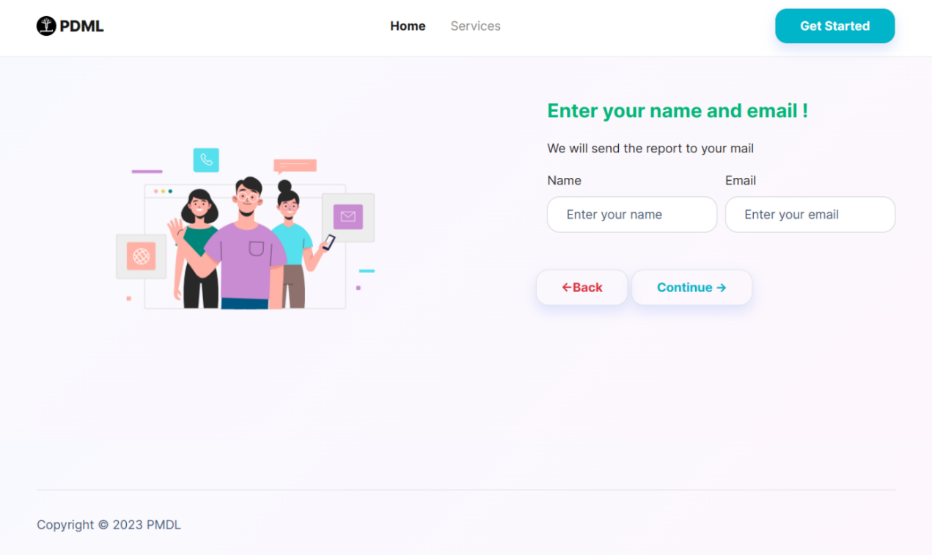

**Fig. 4.5 Enter user details**

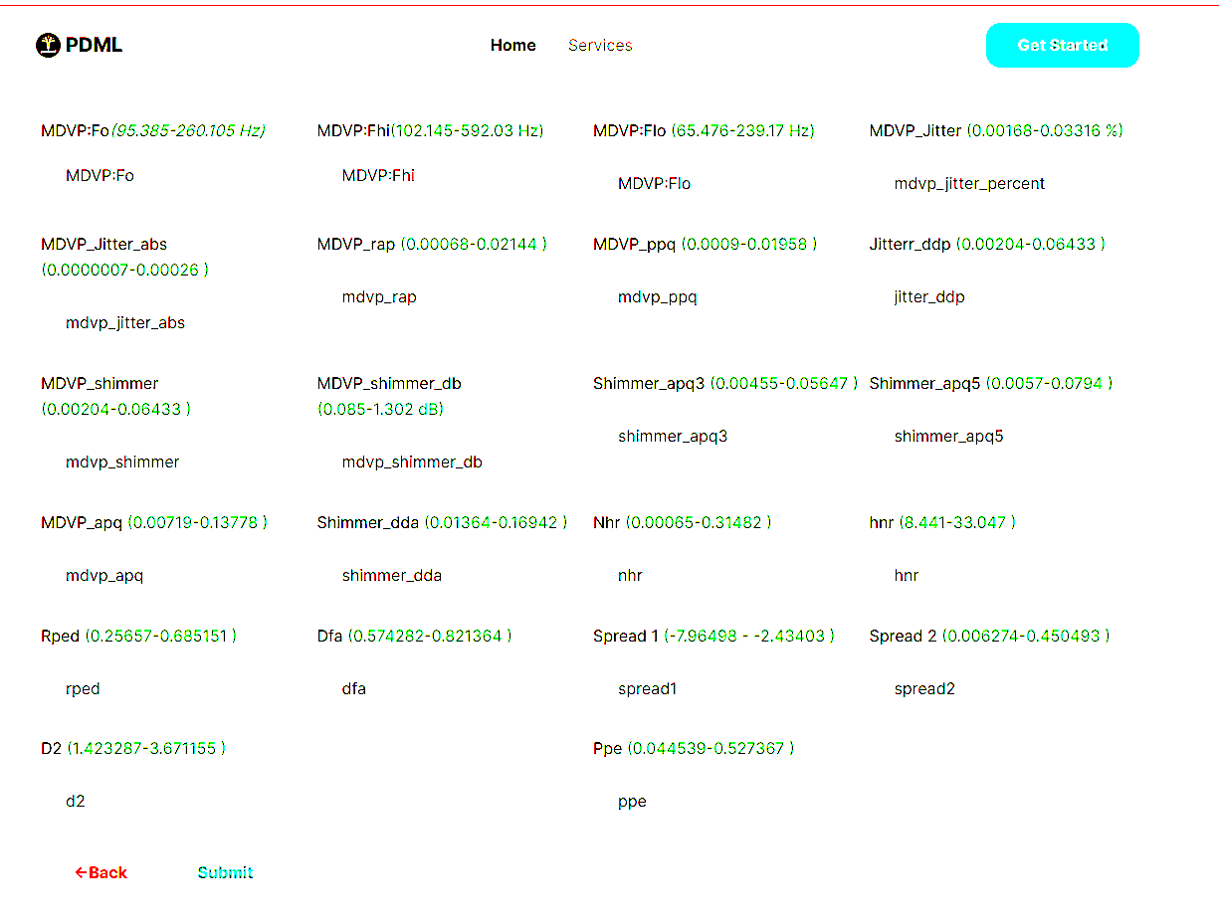

**Fig. 4.6 Data entry**

Fig. 4.6 shows the interface where the facilitator enters the data of the person interested in the diagnosis. There are 22 fields and entering data in all of them is mandatory. These fields contain different frequency measures, jitter and other parameters which play a role in prediction of Parkinson. Table 4.1 illustrates the voice features, their meaning and ranges for normal person.

**Table. 4.1 Vocal features**

|  |  |  |
| --- | --- | --- |
| **Voice Feature** | **Meaning** | **Range** |
| MDVP:Fo(Hz) | Average vocal fundamental frequency | 88-260 |
| MDVP:Fhi(Hz) | Maximum vocal fundamental frequency | 102-592 |
| MDVP:Flo(Hz) | Minimum vocal fundamental frequency | 65-240 |
| fMDVP:Jitter(%) | MDVP jitter in percentage | 0.001-0.033 |
| MDVP:Jitter(Abs) | MDVP absolute jitter in ms | 0.00002-0.0002 |
| MDVP: RAP | MDVP relative amplitude perturbation | 0.0006-0.02 |
| MDVP: PPQ | MDVP five-point period perturbation quotient | 0.0009-0.02 |
| Jitter:DDP | Average absolute difference of differences between jitter cycles | 0.002-0.065 |
| MDVP:Shimmer | MDVP local shimmer | 0.009-0.12 |
| MDVP:Shimmer(dB) | MDVP local shimmer in dB | 0.085-1.302 |
| Shimmer:APQ3 | Three-point amplitude perturbation quotient | 0.004-0.056 |
| Shimmer: APQ5 | Five-point amplitude perturbation quotient | 0.005-0.08 |
| MDVP: APQ11 | MDVP 11-point amplitude perturbation quotient | 0.007-0.14 |
| Shimmer: DDA | Average absolute differences between the amplitudes of consecutive periods | 0.013-0.17 |
| NHR | Noise-to-harmonics ratio | 0.0006-0.31 |
| HNR | Harmonics-to-noise ratio | 8-33 |
| RPDE | Recurrence period density entropy measure | 0.25-0.68 |
| DFA | Signal fractal scaling exponent of detrended fluctuation analysis | 0.57-0.82 |
| spread1 | Two nonlinear measures of fundamental | (-7)-(-2) |
| spread2 | Frequency variation | 0.006-045 |
| D2 | Correlation dimension | 1.42-3.67 |
| PPE | Pitch Period Entropy | 0.04-0.5 |

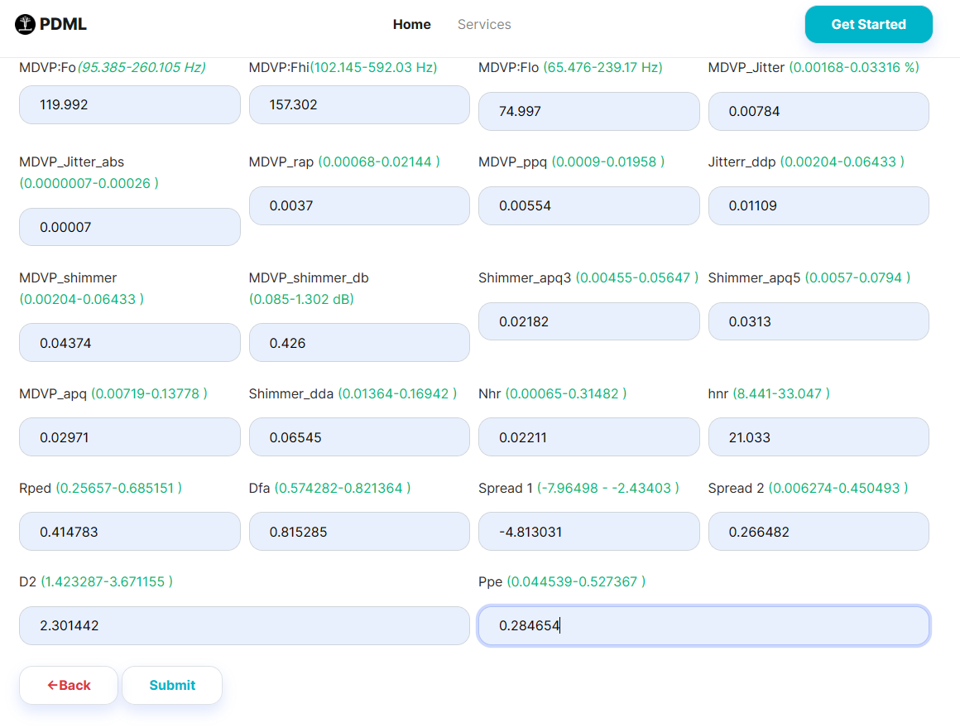

**Fig. 4.7 Entering data-1**

Fig. 4.7 shows the data entered which does not fall into range of normal range. On Clicking on the “submit” button the results are displayed. An intermediate result will be displayed as shown in Fig. 4.8.

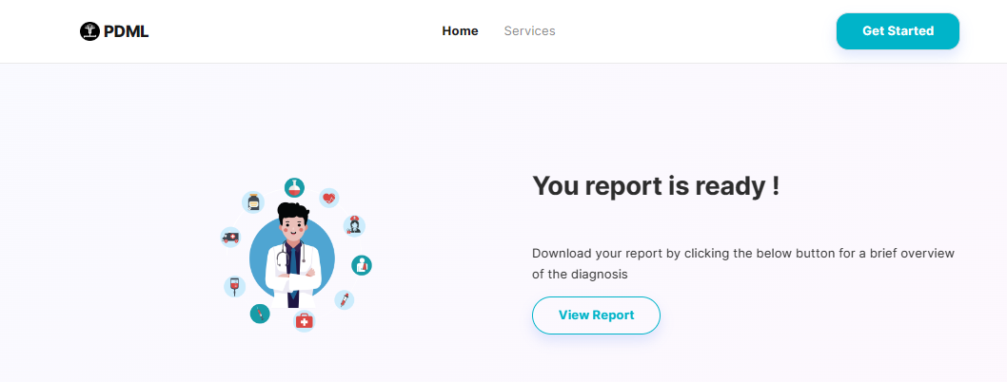

**Fig. 4.8 View report**

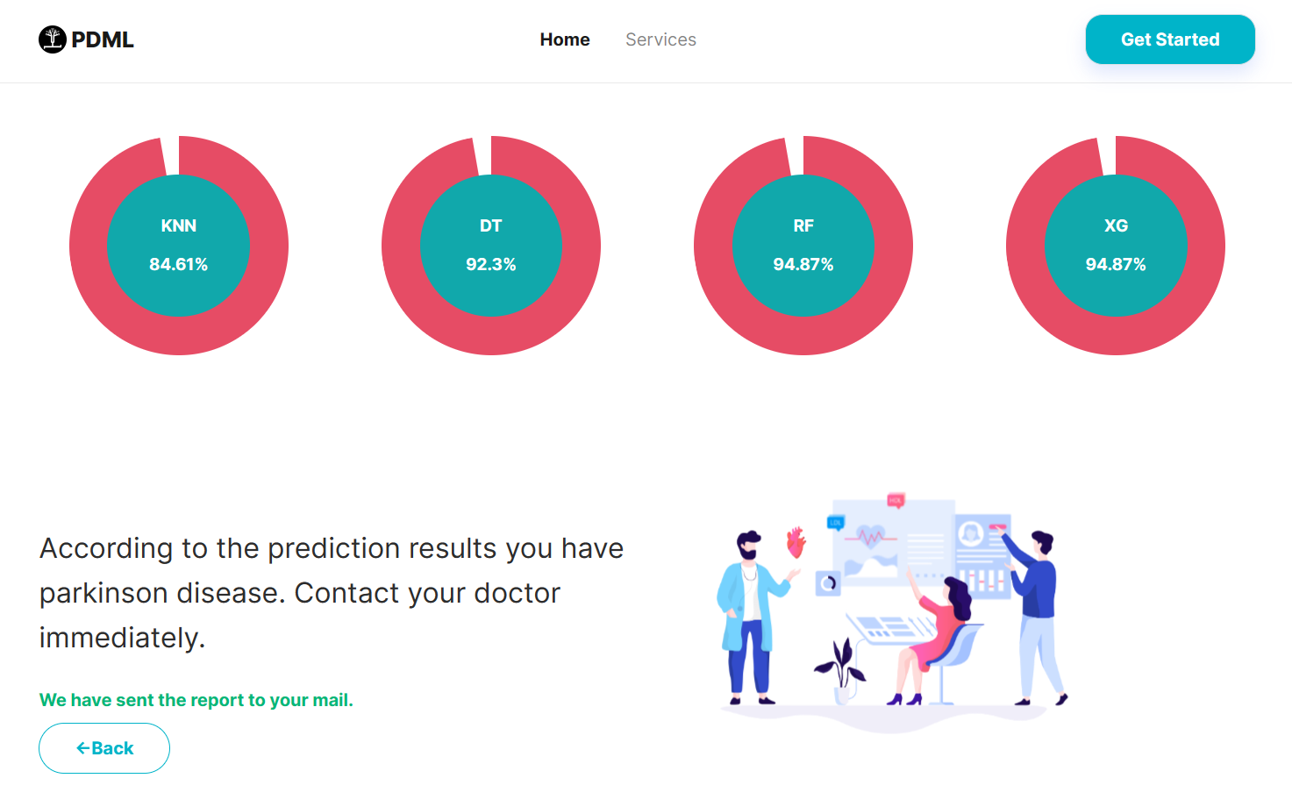

**Fig. 4.9 Results-1**

Fig. 4.9 shows the results for the data entered. Here in this case the user is said to have Parkinson’s according to the predictions and a warning message to contact the doctor is given. At the top all the four models along with their accuracies can be viewed.

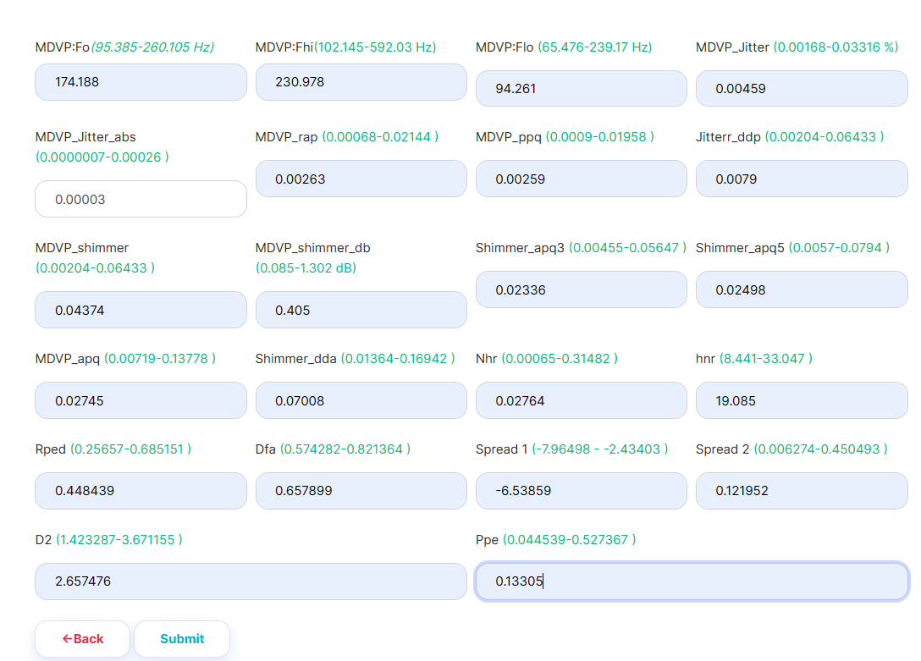

**Fig. 4.10 Enter data-2**

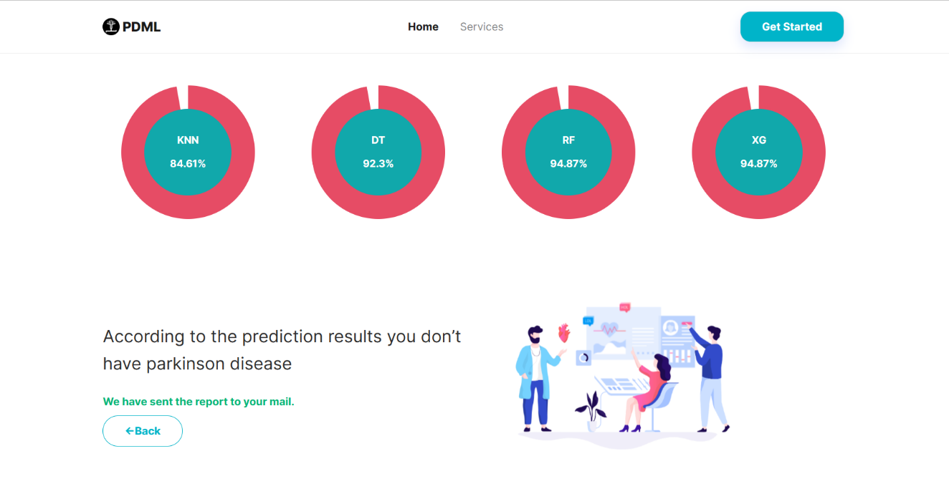

**Fig. 4.11 Results-2**

Fig. 4.10 and Fig. 4. 11 shows another case where the user enters the data there is no sign of Parkinson’s. And a message is displayed informing your detection test has returned a negative result.

**4.2 Predictions using spiral drawings.**

Second type of service provided is prediction using spiral drawing. Fig. 4.12 shows the interface for prediction using spiral drawing. On clicking the next button, General instruction regarding the type of the file to be uploaded, file size, and other needs to be met are specified as shown in Fig. 4.13.

.

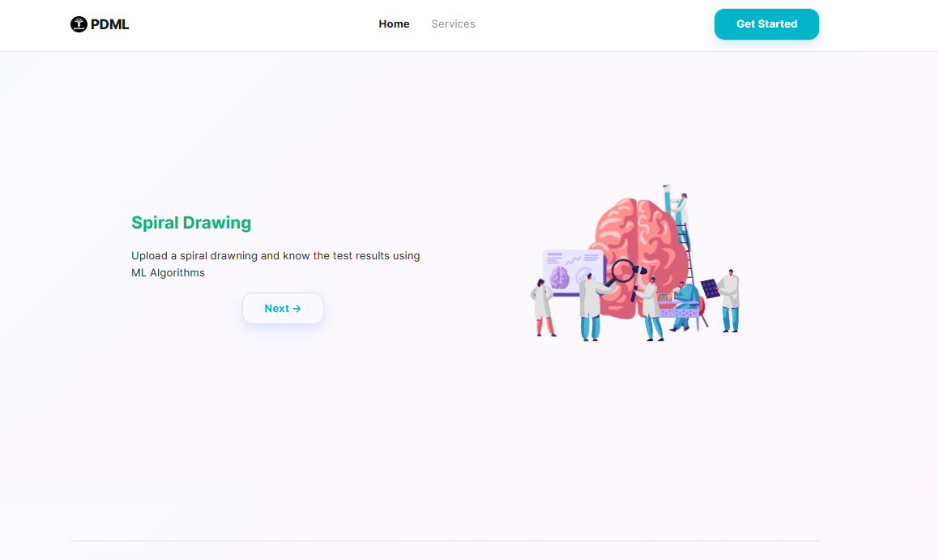

**Fig. 4.12 Interface for spiral**

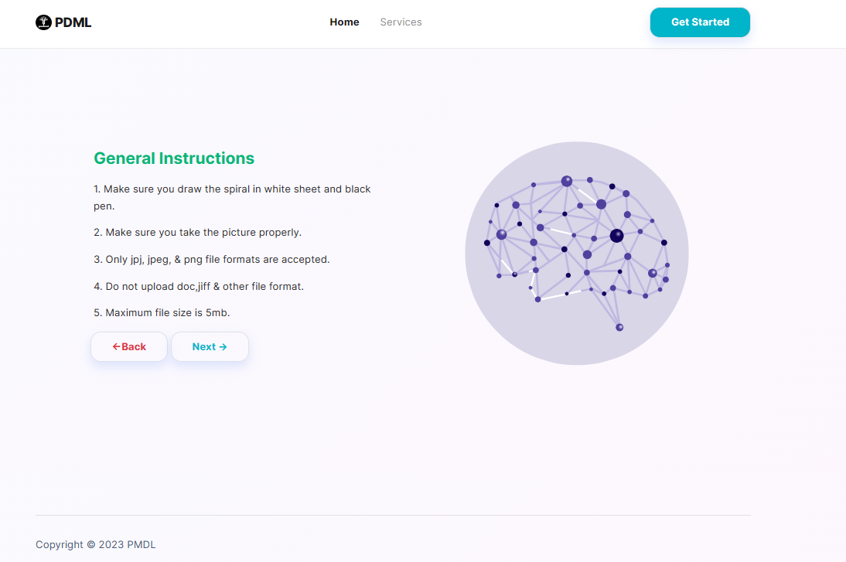

**Fig. 4.13 General Instruction for uploading image**

In Fig. 4.14 name and mail id are collected to send a copy of result to the user. The users spiral drawing must be uploaded which will be used for predictions. Click on “next” button to proceed further and a confirmation regarding if the file was successfully uploaded will be received this is shown in Fig. 4.15.

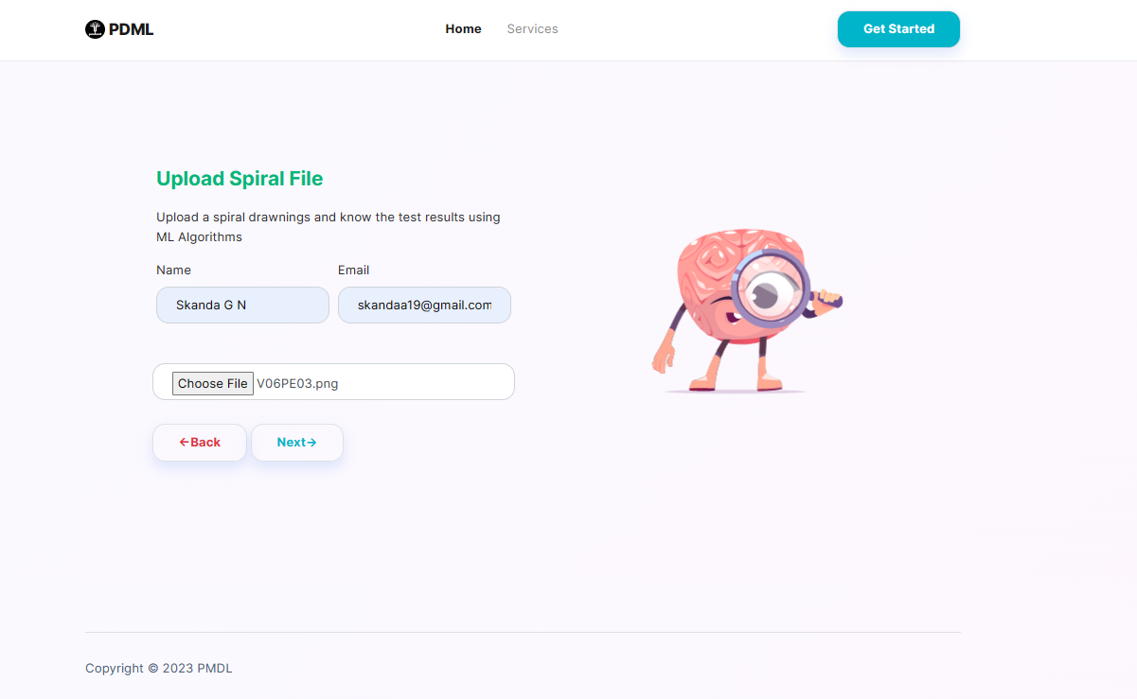

**Fig. 4.14 Spiral drawing input**

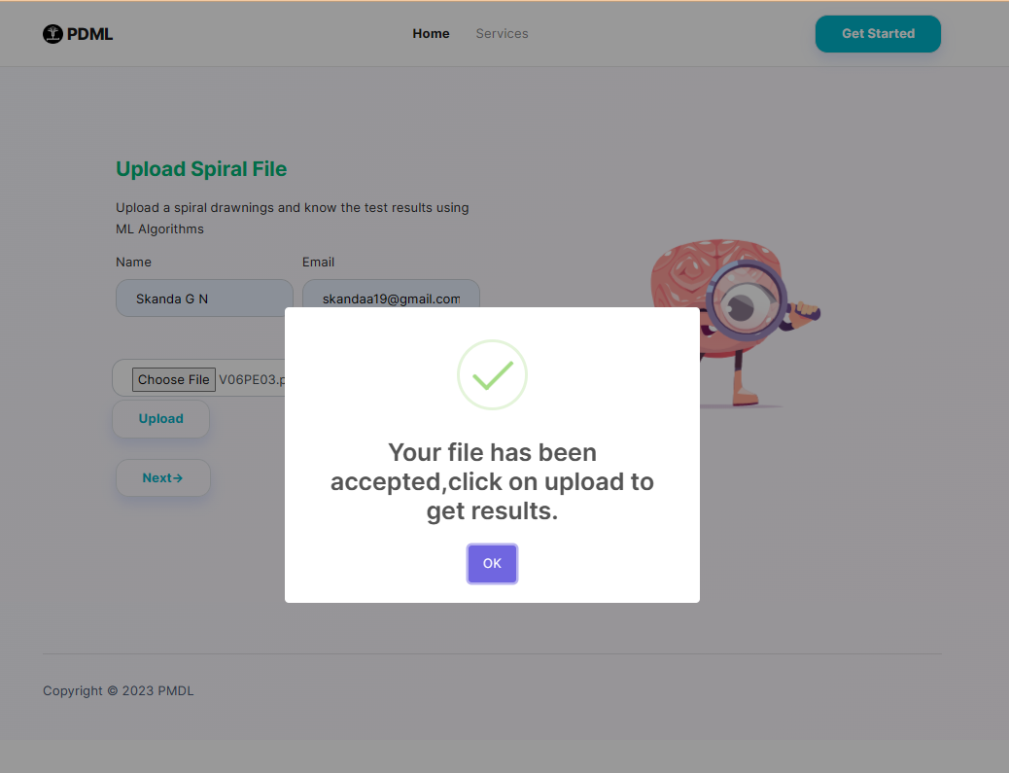

**Fig. 4.15 Confirmation**

Once the file is uploaded successfully on clicking the “Upload” button, the next screen is displayed is shown is Fig. 4.16. On clicking “view report” , the prediction will be displayed.



**Fig. 4.16 View report**

Fig. 4.17 shows the result based on image uploaded. In the case the model has predicted that the user has tested positive, a warning is provided to seek the doctor immediate.

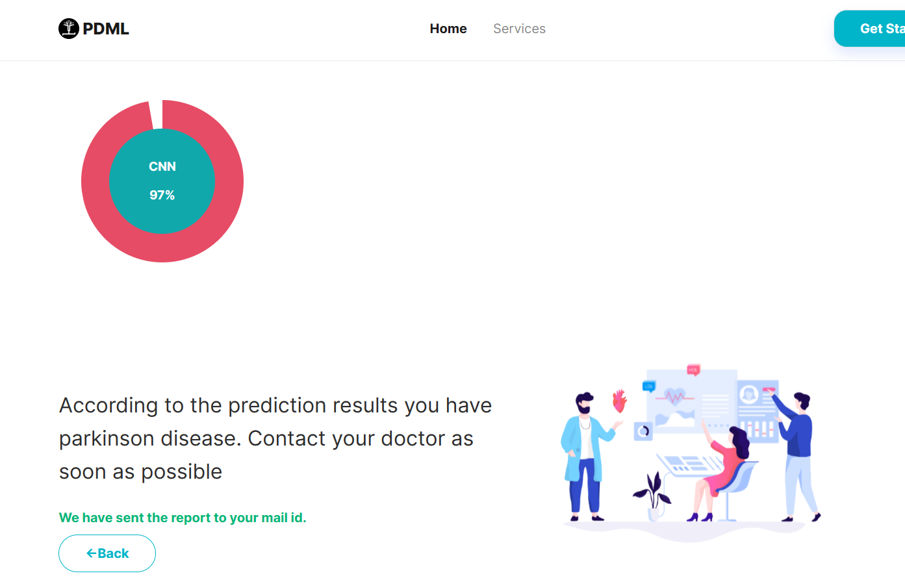

**Fig. 4.17 Positive prediction for spiral**

Fig. 4. 18 shows another test case where a different image is uploaded and the user test negative for Parkinson disease.

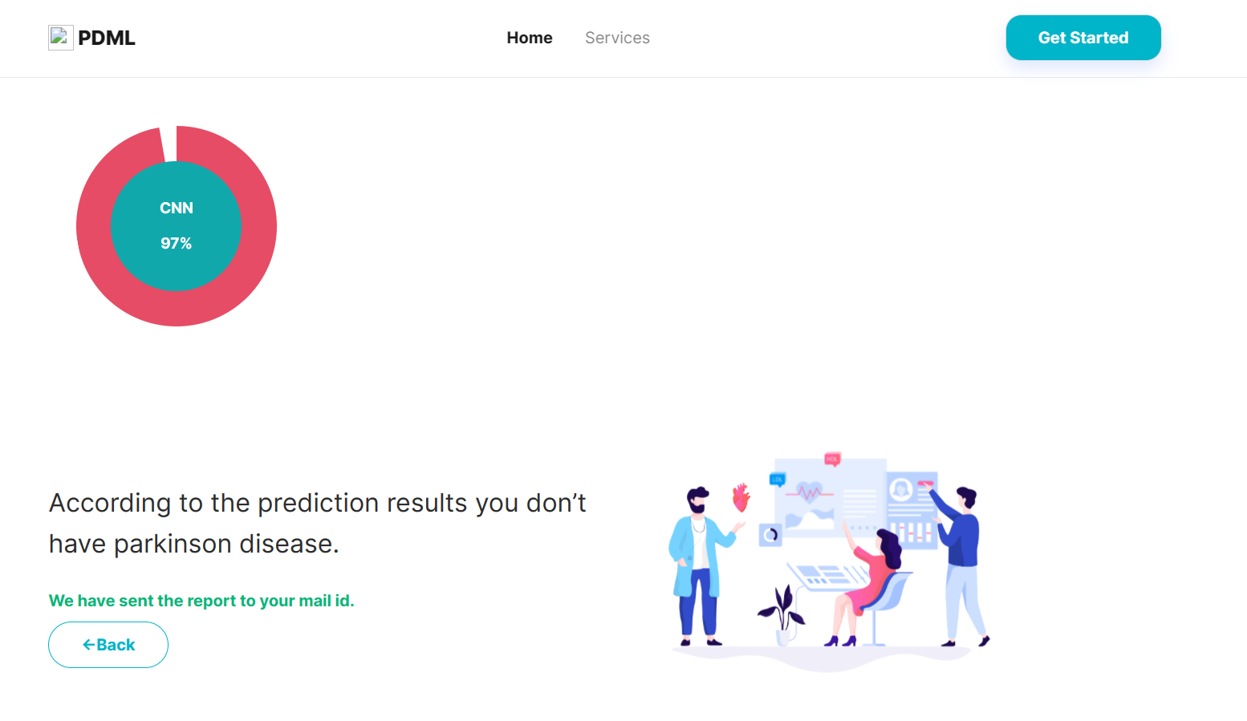

**Fig. 4.18 Negative prediction for spiral**

**4.3 Mailer**

Each time a user checks for Parkinson his/her name and email id is collected so that results of the test is sent to the mail id given. This is implemented using flask mailer.

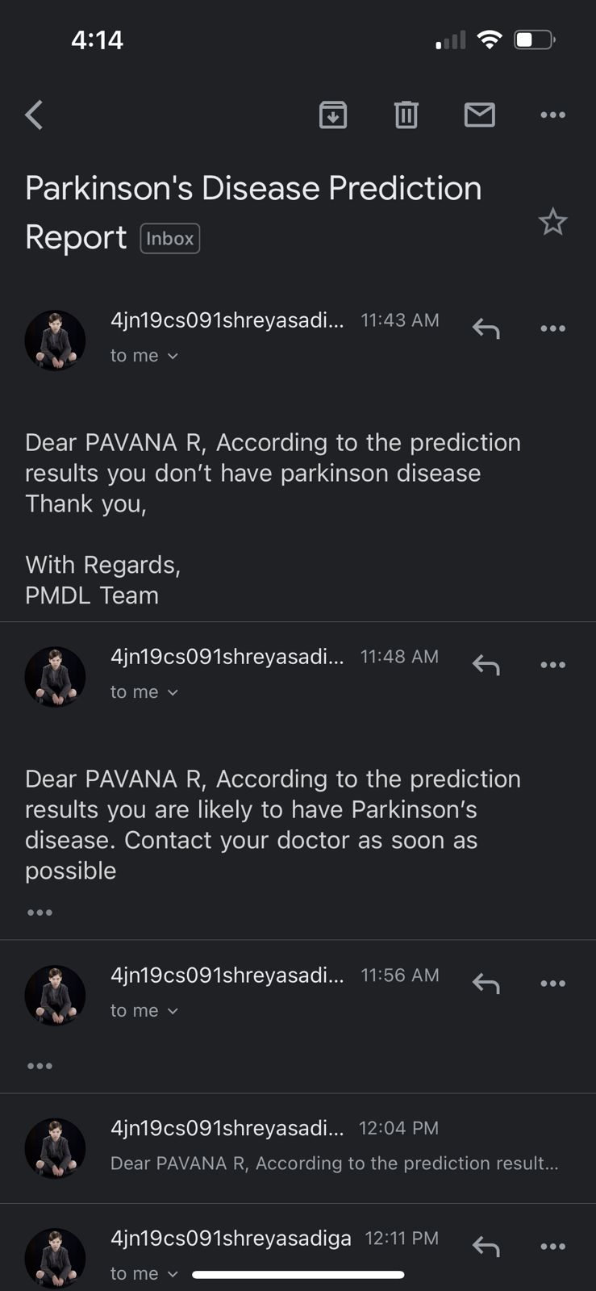

**Fig. 4.19 Mail for negative results**

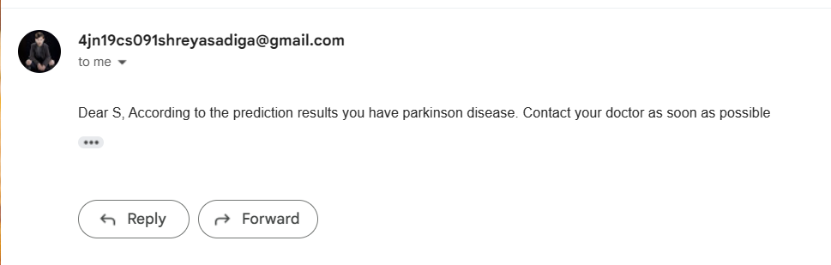

**Fig. 4.20 Mail for positive results**

Fig. 4.19 shows the mail received by the user who tested negative, and Fig. 4.20 shows the mail received by the user who tested positive.

**4.4 Telegram chat bot**

A telegram chat bot facility is provided that helps you all the way though you detection. Fig. 4. 21 shows the PDML chat bot.

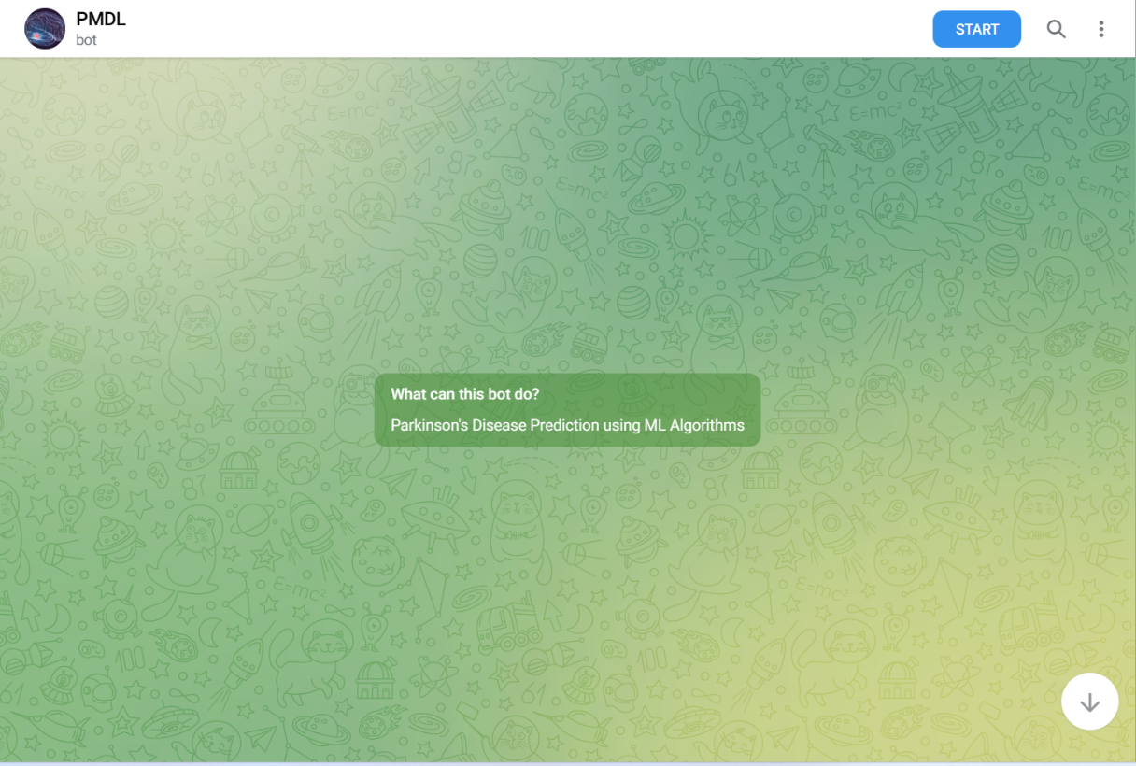

**Fig. 4.21 Chat bot**

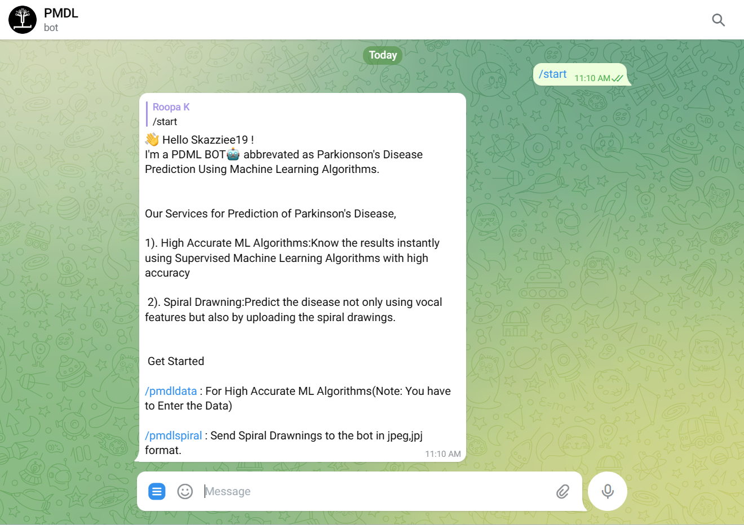

**Fig. 4.22 Start the bot**

To initiate the chat with the bot, send a “/start” text or click on the start button at the top. This action is shown in Fig. 4.22. An explanation regarding the services and commands to proceed further with the prediction is given.

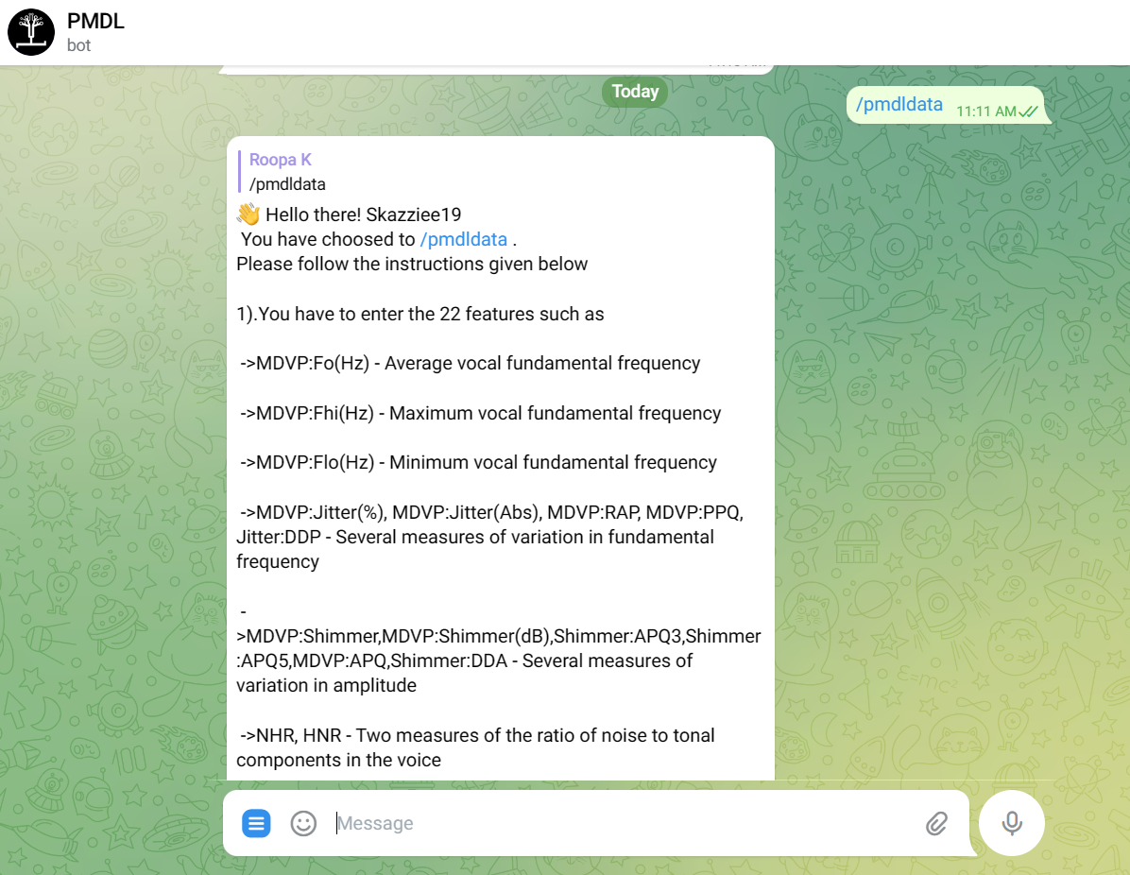

**Fig. 4.23 Prediction using speech data**

For prediction of Parkinson disease using speech data “/pmdldata” option can be selected as shown in Fig. 4.23. A list of instruction to be followed, explanation of the features and the format to enter the data is given out.

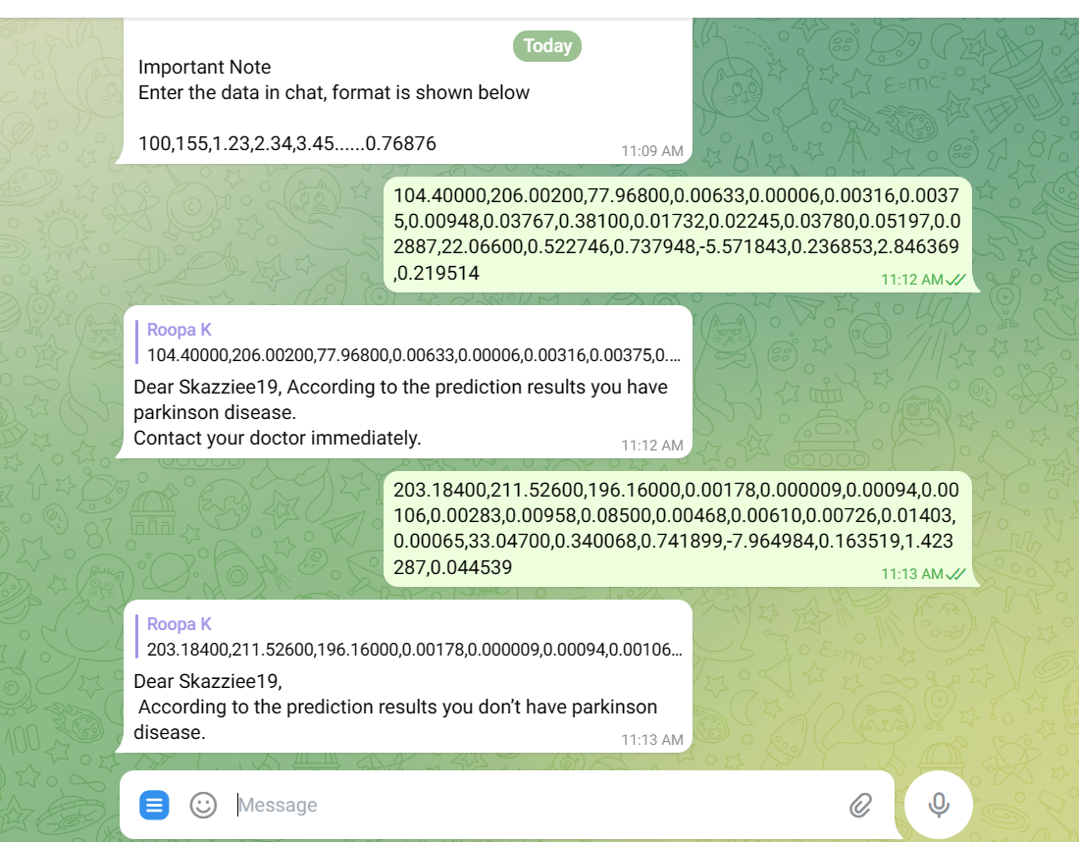

**Fig. 4.24 Prediction using speech data**

Fig. 4.24 shows two different cases where the user has entered the vocal values. In the first case the predication is Parkinson detected and in the second case there is no sign of Parkinson disease.

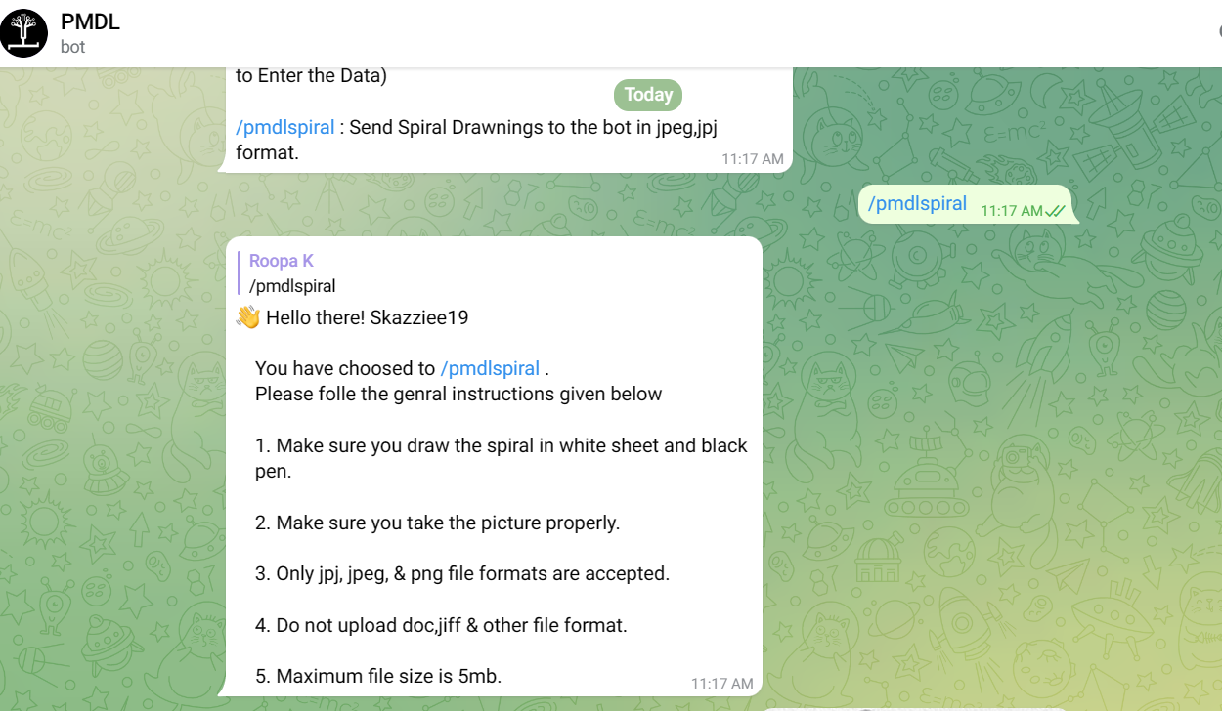

**Fig. 4.25 Prediction using spiral drawings**

“/pmdlspiral” command can be used for prediction using spiral drawings. This is shown in Fig. 4.25 and a set of instructions regarding the file size and format to be uploaded is given.

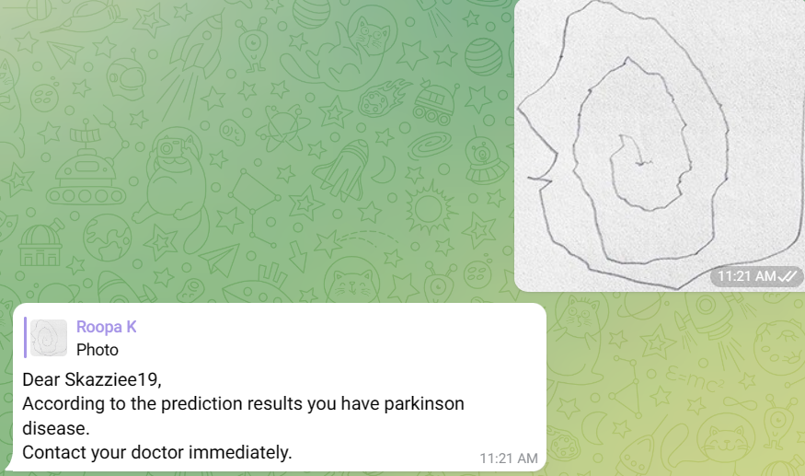

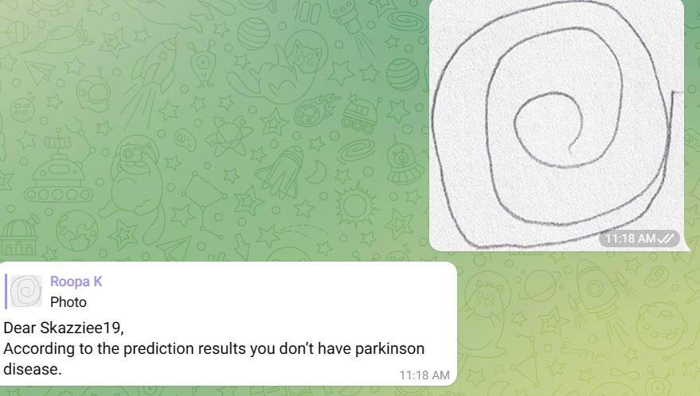

**Fig. 4.26 Input spiral drawings**

In Fig. 4. 26 two different figures are given for prediction purpose and corresponding results for them are obtained. First prediction is where the user has Parkinson based on this spiral drawing.

**4.5 Analysis and discussion**

As a part of pre-processing the obtained speech dataset, it was checked for null values by plotting a heat map. This is performed by making use of the pandas, seaborn and matplotlib libraries. Upon uploading the dataset isNull() function is made use. From Fig. 4.27 it can be inferred that no null values are present in that dataset.

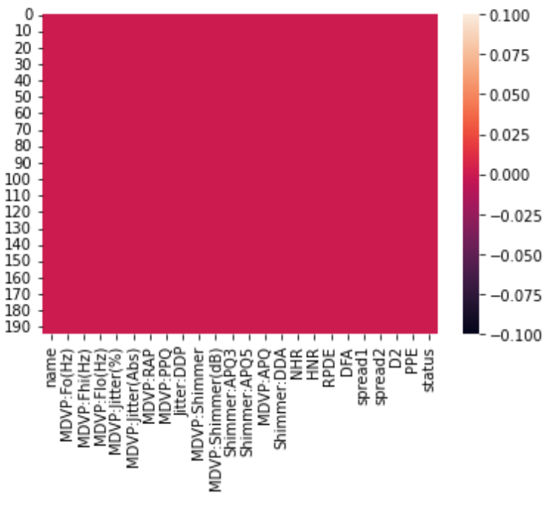

**Fig. 4.27 Checking for null values**

While training the models, it was observed that different values for each parameter results in different accuracy, recall, precision and F1-score measures. These parameters were experimented with different values so that a suitable value could be found in which the model results in highest accuracy. Also, the way in which the dataset was split also had an impact on these values

**Table. 4.2 Analysing different evaluation metrics value for decision tree**

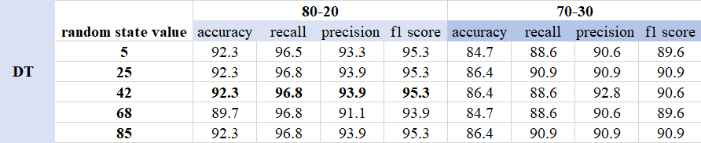

Different random state values outputted in different accuracies and recall, precession and F1-Score values kept on changing which is shown in Table. 4.2. Five different random state values and two possibilities for splits was considered. From the table it can be observed that when the dataset is split in 80-20 and random state is set to 42 the model performed well.

**Table. 4.3 Analysing different evaluation metrics value for KNN**

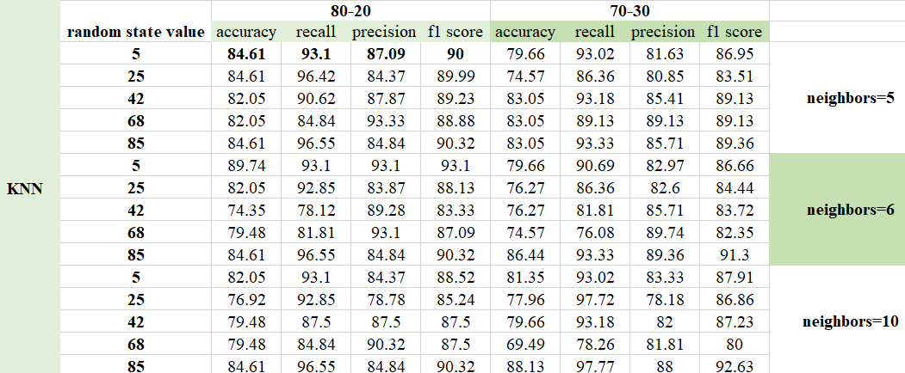

Similarly for the model trained on KNN algorithm, the neighbors value was set to 5, 6 and 10 and five different random state values were applied respectfully to each neighbors value. Table. 4.3 shows the results Looking from the values in the table it can be concluded that the model performed well when the dataset was split in 8:2 and random state and neighbors is set to 5.

**Table. 4.4 Analysing different evaluation metrics value for XG Boost**

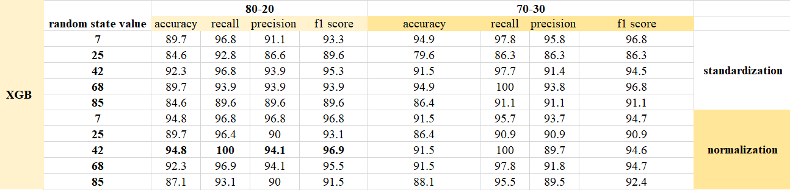

For XG boost algorithm both standardization and normalization was.The model performed well when the data was normalized, random state set to 42 and data split in 80-20. For training the model with random forest algorithm a new parameter had to be analysed this new parameter her is- n_estimator. This specifies the number of decisions trees to be implemented of different subsets of data.

**Table. 4.5 Analysing metric value for Random forest-standardization**

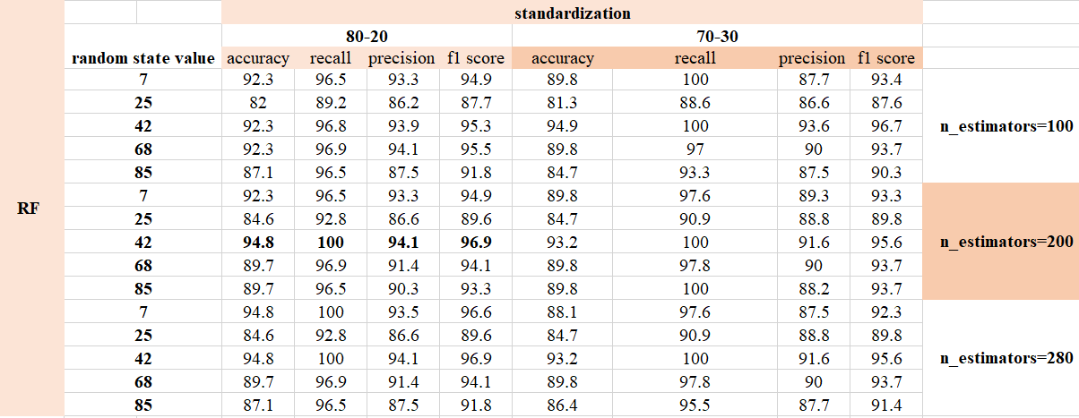

**Table. 4.6 Analysing metric value for Random forest-normalization**

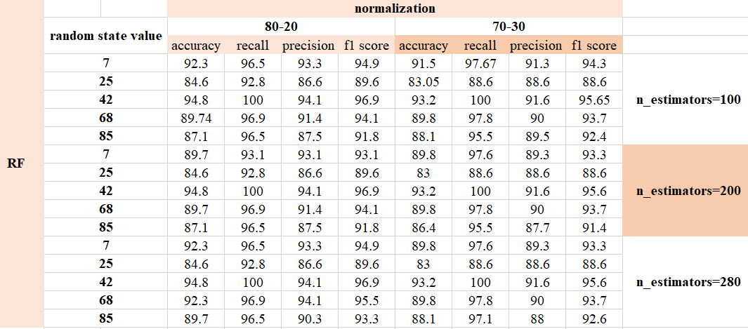

Results for three different n_estimators were noted down that is 100, 200 and 280. Table. 4.5 shows the results obtained when standardization was applied and Table. 4.6 shoes the results obtained when normalization was applied. On comparing values from both the tables it can be concluded that the model worked well when n_estimators value was set to 200, random state to 42, data split into 80-20 and when its standardized.

**Table. 4.7 Summarizing the values of all paramenters**

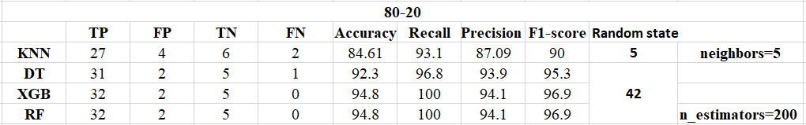

While training the models in the system, the audio dataset was split in the ration 80:20 for training and testing respectively. Also, standardization and normalization were applied while training the XG Boost and random forest models respectively. Random state and the number of neighbours was set to 5 in KNN. For training of the rest three models, random state was set to 42 and n_estimators was set to 200 in random forest. Table. 4.7 shows TP, FP, TN, FN accuracy, recall, precision and F1-score values for all the models when the above mention values for the parameters are set.

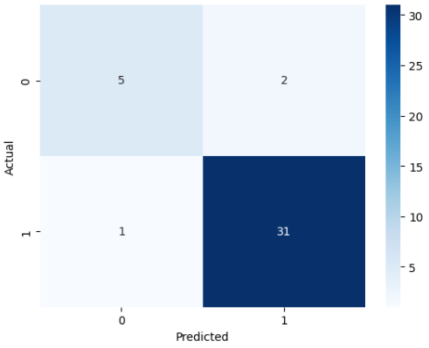

**Fig. 4. 28 Confusion matrix for DT**

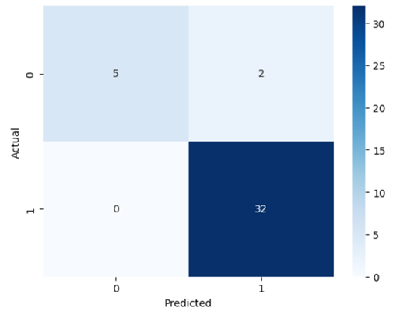

**Fig. 4.29 Confusion matrix for RF and XGB**

With the help of TP, FP, TN and FP values a confusion matrix was plotted. Fig. 4.28 shows the confusion matrix for decision tree and Fig. 4.29 shows confusion matrix for random forest and XG Boost. Fig. 4.30 shows confusion matrix for the model trained on KNN algorithm. The sum of TP+FP+TN+FP is always equal to the number of instances used for testing.

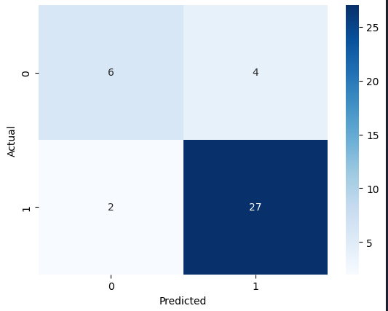

**Fig. 4.30 Confusion matrix for KNN**

**4.6 Summary**

In this chapter the working of web application for prediction using speech data and spiral drawing was explained. This section was followed by snap shots telegram bot. Finally, the results were analysed based on how the dataset was split and how different values for parameters affected the evaluation metrics.

**.**

**Chapter 5**

**CONCLUSION**

**5.1 Conclusion**

Parkinson's disease remains a relentlessly progressive neurodegenerative disorder, with patients increasingly troubled by motor and non-motor problems as the disease progresses. Managing Parkinson's disease in day-to-day life is very challenging for an individual. A good screening procedure would be beneficial, especially in circumstances where a physician's treatment is not necessary. On studying several researchers engaged in the field of Parkinson's disease detection during the survey, different ways to diagnose Pakinsons were found and analyzed .

In this project, the occurrence of the Parkinson’s Disease is predicted using two datasets, one containing the voice features of the patient and the other composed of spiral drawings. Out of four algorithms used to detect the disease using voice dataset XGBoost, RF and KNN showed the highest accuracy of 94.87%, followed by DT with 92.3% accuracy. In addition to this, the CNN algorithm with transfer learning showed the highest accuracy of 98% in predicting the disease using spiral dataset. Detecting the disease in the early stage could be a great help to the affected people. After using more data, the work will have more hidden patterns and dimensions. An application is developed for an individual or whole organization for medical purposes.

**5.2 Future Scope**

* New technologies can be created to make it easier to generate speech datasets.
* For the spiral dataset, the training dataset may be expanded with more and more images to improve prediction and accuracy.
* More data is needed from different regions around the globe with patients having an early stage of Parkinson to improve the reliability and the robustness of the models. Another way that may improve the performance of the system is applying ensemble learning with more classification algorithms, such as, the support vector machines, enhanced k-nearest neighbours and kernel dictionary learning.

**REFERENCES**

|  |  |
| --- | --- |
| [1] | Amreen Khanum D, Prof. Kavitha G and Prof. Mamatha H S, “Parkinson’s Detection using Machine Learning Algorithms”, International Journal for Research in Applied Science & Engineering Technology (IJRASET), ISSN: 2321- 9653 vol 10 Issue X, pp 786-790, Oct 2022 |
| [2] | Mohesh T,Gowtham K,Vijeesh P and Arun Kumar S, “Parkinson’s Disease Prediction Using Machine Learning”,IJRASET44075,ISSN:2321-9653,vol 10 Issue VI,2022. |
| [3] | S. Kamoji, D. Koshti, V. V. Dmello, A. A. Kudel and N. R. Vaz*, "*Prediction of Parkinson's Disease using Machine Learning and Deep Transfer Learning from different FeatureSets,"2021 6th International Conference on Communication and Electronics Systems (ICCES)*, pp.* 1715-1720, 2021*.* |
| [4] | S. Chakraborty, S. Aich, Jong-Seong-Sim, E. Han, J. Park and H. -C. Kim, "Parkinson's Disease Detection from Spiral and Wave Drawings using Convolutional Neural Networks: A Multistage Classifier Approach," 2020 22nd International Conference on Advanced Communication Technology (ICACT), pp. 298-303, 2020. doi: 10.23919/ICACT48636.2020.9061497. |
| [5] | Anitha R,Nandhini T, Sathish Raj S and Nikitha V, “Early Detection Of Parkinson’s Disease Using Machine Learning”,IJARIIE,ISSN(O):2395-4396, Vol 6 Issue 2, pp 505-511,2020. |
| [6] | Sanghee Moon, Hyun-Je Song, Vibhash D. Sharma, Kelly E. Lyons, Rajesh Pahwa, Abiodun E. Akinwuntan and Hannes Devos. “Classification of Parkinson’s disease and essential tremor based on balance and gait characteristics from wearable motion sensors via machine learning techniques: a data-driven approach” Journal of Neuro Engineering and Rehabilitation, ISSN: 1743-0003, vol 17, Issue 1,2020 |
| [7] | Korakanchi Madhu Mohan Rao, Mallavarapu Sai Naveen Reddy, Vemula Ravi Teja, Padmaveni Krishnan, D. John Aravindhar, M. Sambath “Parkinson's Disease Detection Using Voice and Spiral Drawing Dataset.”  Third International Conference on Smart Systems and Inventive Technology (ICSSIT),pp 787-791,2020. |
| [8] | Basil K Varghese, Geraldine Bessie Amali D and Uma Devi K S. “Prediction of Parkinson’s Disease using Machine Learning Techniques on Speech dataset” Research Journal of Pharmacy and Technology, vol 12 Issue (2), pp 644- 648,2019. |
| [9] | T. J. Wroge, Y. Özkanca, C. Demiroglu, D. Si, D. C. Atkins and R. H. Ghomi, “Parkinson’s Disease Diagnosis Using Machine Learning and Voice”, IEEE Signal Processing in Medicine and Biology Symposium (SPMB), ISSN: 2372- 7241, pp. 1-7, 2018. |
| [10] | Srishti Grover, Saloni Bhartia, Akshama, Abhilasha Yadav and Seeja K. R, “Predicting Severity of Parkinson's Disease Using Deep Learning”, International Conference on Computational Intelligence and Data Science (ICCIDS), vol 132, pp 1788–1794,2018. |
| [11] | Tarigoppula V.S Sriram, M. Venkateswara Rao, G V Satya Narayana, DSVGK Kaladhar and T Pandu Ranga Vital, “Intelligent Parkinson Disease Prediction Using Machine Learning Algorithms”, IJEIT, vol 3, pp 212-215,2013. |
| [12] | Muhtasim Shafi and Fizar Ahmed, “Parkinson’s Disease Detection Analysis through Machine Learning Approaches” https://www.researchgate.net/publication/359711136, 2022. |
| [13] | Sonia Singla, “Parkinson disease onset detection Using Machine Learning”, https://www.analyticsvidhya.com/blog/2021/07/parkinson-disease-onset detection-using-machine-learning/,2022. |
| [14] | Oduntan Ifeoma, “Prediction of Parkinson's Disease Using Biomedical Voice Measurements Dataset”, https://www.researc hgate.net/publication/35725620,2021. |
| [15] | Pramanik Anik and Sarker Amlan, “Parkinson's Disease Detection from Voice and Speech Data Using Machine Learning”, https://www.researchgate.net/publication/347520593,2020. |
| [16] | https://www.javatpoint.com/machine-learning-support-vector-machine-algorithm |
| [17] | Convolutional Neural Network (CNN) in Machine Learning - GeeksforGeeks |
| [18] | Introduction to Docker - GeeksforGeeks |

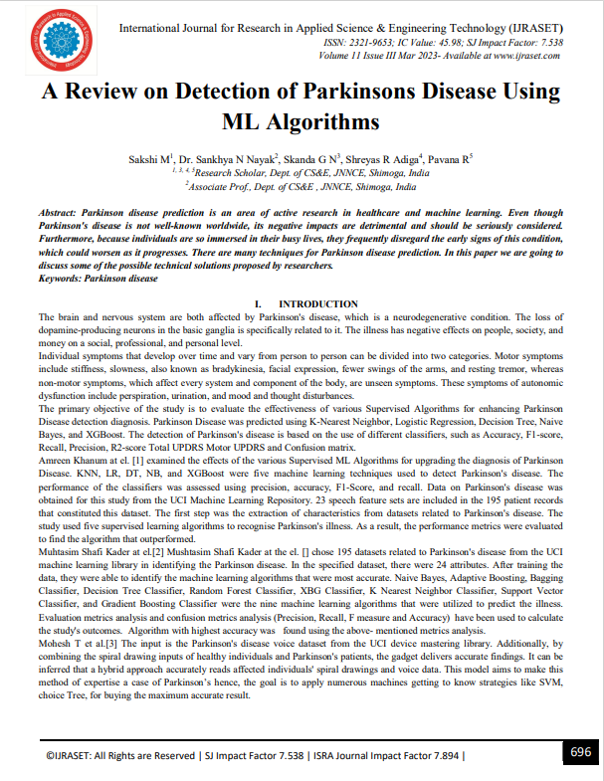

**Appendix A**

|  |  |  |
| --- | --- | --- |
| |  | | --- | | **Parkinson’s Data Set** | |  | |

This dataset is obtained from UCIML Repository. It consists of 195 instances and 23 attributes. The dataset was created by Max Little of the University of Oxford, in collaboration with the National Centre for Voice and Speech, Denver, Colorado, who recorded the speech signals. The original study published the feature extraction methods for general voice disorders. This dataset is composed of a range of biomedical voice measurements from 31 people, 23 with Parkinson's disease (PD). Each column in the table is a particular voice measure, and each row corresponds one of 195 voices recording from these individuals ("name" column). The main aim of the data is to discriminate healthy people from those with PD, according to "status" column which is set to 0 for healthy and 1 for PD. The data is in ASCII CSV format. The rows of the CSV file contain an instance corresponding to one voice recording. There are around six recordings per patient, the name of the patient is identified in the first column. This dataset does not contain any null values.

**Attribute information:**

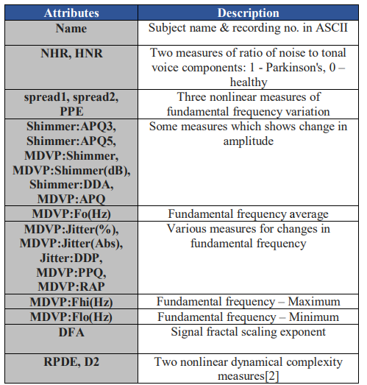

**Dataset link:** https://archive.ics.uci.edu/ml/datasets/Parkinsons

**Parkinson's Drawings**

This dataset is obtained from Kaggle. It consists of images of both healthy and Parkinson patient. The dataset is already split into training and testing data. Where training dataset consists of 36 images each for healthy and Parkinson. And testing data consists of 15 images each for healthy and Parkinson.

 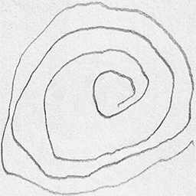

The above images are taken from the dataset where the one of the left is drawn by a healthy person and the one on right is from a patient suffering from Parkinson’s.

**Dataset link:** https://www.kaggle.com/datasets/kmader/parkinsons-drawings